Mini Project Report

(2020-2021)

Friends & Family Restraunt



**Department of Computer Engineering & Applications**

**Institute of Engineering and Technology**

**Submitted by:**

Vipul (181500801)

Umesh Pratap Singh (181500767)

Arvind Jaiswal (181500133)

Satyam Singh (181500629)

**Supervised By:**

**Dr. Mandeep Singh**

**Technical Trainer**

**Department of Computer Engineering and Application**



**Department of computer Engineering and Applications**

**GLA University, Mathura**

**17 km. Stone NH#2, Mathura-Delhi Road, P.O. – Chaumuha,**

**Mathura – 281406**

**Declaration**

We hereby declare that the work which is being presented in the Mini Project II **“**Friends & Family Restraunt**”,** in partial full fillment of the requirements for Mini Project viva voce, is an authentic record of our own work carried under the supervision of **Mr. Mandeep Singh, Assistant Professor, GLA University, Mathura.**

Arvind Jaiswal (181500133)

Sign: _____________

Satyam Singh (181500629)

Sign: _____________

Vipul (181500801)

Sign: _____________

Umesh Pratap Singh (181500767)

Sign: _____________

Course: B.Tech(CSE)

Year: 3rd

Semester: V

Members GitHub Id’s:

* https://github.com/Satyamsingh99
* https://github.com/vipulgupta22
* https://github.com/Arvindjaiswal723
* https://github.com/thakurups



**Certificate**

This is to certify that the project entitled “Friends & Family Restraunt” carried out in Mini Project II is the work done by Satyam Singh, Vipul, Arvind Jaiswal, Umesh Pratap Singh and is submitted in partial full fillment of the requirements for the award of degree Bachelor of Technology (Computer Science and Engineering).

Signature of Supervisor:

Name of Supervisor: Dr. Mandeep Singh

Date:

**Acknowledgement**

It is our pleasure to acknowledge the assistance of a number of people without whose help this project would not have been possible.

First and foremost, We I would like to express our gratitude to **Dr. Mandeep Singh** our project mentor, for providing invaluable Encouragement, guidance and assistance. We would like to thank my co-team members for their complete support throughout in finishing the mentioned project accurately. After doing this project We can confidently say that this experience has not only enriched us with technical knowledge but also has unparsed the maturity of thought and vision, the attributes required for being a professional.

**Abstract**

Restaurant is a kind of business that serves people all over world with readymade food. Currently this industry is going on with lot of flare. People feel more comfortable with lot of variations in the selection and consumption of their food in their busy life.

One can see lot more restaurant in the world. Even in India one can see thousands of restaurants with dishes from all over the world like from America, Japan, Turkey, etc fulfilling the needs of people with nourishments and enjoyments.

Let’s concentrate on booking area in a restaurant. In traditional booking system, a customer has to make a phone call in order to get his meal reserved. If luckily the phone gets connected, then the customer does some formal conversation like hello, hi, etc. Then he demands for today’s menu and do some discussion over menu items then he orders and he has to give some of this identification specifications. This process takes 5-8 minutes to complete. On the receiver side there is hardly one phone line and one operator. So he can cover around 15-20 orders maximum in an hour.

For each booking he has to register manually on paper and puts the order in a queue with specific priority according to time and quantity, and then a cook is assigned for the specific order to complete it. But our problem lies within domain of end customer and restaurant.

**Table of Contents**

**Declaration…………………………………………………………………………….2**

**Certificate……...…………………………………………………………………........3**

**Acknowledgement……………………………………………….…………………….4**

**Abstract………………………………………………………………………………...5**

**Table of Content……………………………………………………………….............6**

**1. Introduction**

1.1 Overview…………………………………….………………………………….... ..7

1.2 Motivation….…………………………………...…………………………….……7

1.3 Project Plan……………………………………….…………………………………7

1.3.1 Objective

1.3.2 Scope

1.4 Drawbacks in existing system……………………….……………………………..8

**2. Software**

2.1 Hardware Requirements………………………………….………………………. 9

2.2 Software Requirements……………………………….…….……………………. 9

2.3 Installation of VS Code………………………………………...…………………. 9

2.4 Specific Requirements…………………………………………………………….10

2.4.1 Language Used………………………………………………………………….10

**3. Software Design**

3.1 Use Case Diagram……………………………………………………………. ….. 12

3.2 Data Flow Diagram………………………………….…………………………… .12

**4. Testing**

4.1 Introduction.…………………………………………………………….………….14

4.2 Error……...…………………………………….………………………….……….14

4.3 Fault…………….…………………………………………………….…. ….…….14

4.4 Failure……………………...……………………………………………….……...14

4.5 Functional Test…………….…………………………………………….………...15

4.6 Performance Test………………….……………………………………………….15

4.7 Stress Test………………………………………………………………………….15

4.8 Structure Test………………………………………………………………….…...15

**5. Implementation and User Interface…………………………………………….16-35**

**6. Contributions……………………………………………………………………….36**

**7. References/Bibliography……………………….…………………………………..36**

**Chapter-1**

**Introduction**

**1.1. Overview**

Online Restaurant management system is the system for manage the restaurant business. The main point of developing this system is to help restaurant administrator manage the restaurant business and help customer for online ordering and reserve table. The project is developing because; many restaurants have a lot difficult to manage the business such as customer ordering and reservation table. By using manual customer ordering is difficult to waiter keep the correct customer information and maybe loss the customer information. So, online restaurant management system will develop to help the restaurant administrator to manage restaurant management and for customer make their online ordering and reservation table. Other than that, this project is to upgrade the manual system and make the business easily to access and systematic.

**1.2. Motivation**

Nowadays, many restaurants manage their business by manual especially take customer ordering. Today, restaurant waiter takes the customer ordering by manual system with using paper. This is problem for restaurant waiter the probability lost and duplicates customer information. Additionally, it would affect to reputation restaurant in operate management of ordering. hides, the restaurant waiter information also by manual system kept use paper and this is difficult for restaurant administrator to find waiter information, probability missing the paper and difficult to arrange the schedule. Sometimes, waiter information and customer information is important to restaurant administrator for reference in the future. Furthermore, restaurant side needs management in the section menu. This is the important to restaurant waiter to manage the menu. Besides this section is for customer viewer the menu that restaurant prepared and make their ordering. As a result, the current system (manual system) is not effective and efficient to use anymore because the current system cannot save, manage and monitor the restaurant waiter information, menu information, customer ordering information and generate report well.

**1.3. Project Plan**

**1.3.1. Objective**

Friends and Family Restraunt is a website designed primarily for use in the food delivery industry. This system will allow hotels and restaurants to increase scope of business by reducing the labor cost involved. The system also allows to quickly and easily manage an online menu which customers can browse and use to place orders

with just few clicks. Restaurant employees then use these orders through an easy to navigate graphical interface for efficient processing.

**1.3.2. Scope**

The project is developing because; many restaurants have a lot difficult to manage the business such as customer ordering and reservation table. If the customer book an order and later wants to cancel the order, he is permitted to do this only within a specific time period. By using manual customer ordering is difficult to waiter keep the correct customer information and maybe loss the customer information. The customer is also given with the facility to view the status of the order and if the order is ready then he can go and get it.

**1.4. Drawbacks in Existing System**

* Add to Cart Option is not available.
* Payment Option is available but not in service.
* Not on HTTPS encryptions.

**Chapter-2**

**Software Requirement Analysis**

**2.1. Hardware Requirements**

• Pentium Processor

• 60 MB of free hard-drive space

• 128 MB of RAM

**2.2. Software Requirements**

• Operating System: Windows (Vista/7 or above)

• Web Browser: IE 10 or above, Mozilla FF 31 or Google Chrome

• Drivers: Java Runtime Environment

• Tools: GitHub, VSCode

• Front-end: HTML, CSS, JavaScript

**2.3. Installation of VS Code**

VS Code is a free code editor, which runs on the macOS, Linux, and Windows operating systems.

VS Code is lightweight and should run on most available hardware and platform versions. You can review the System Requirements to check if your computer configuration is supported.

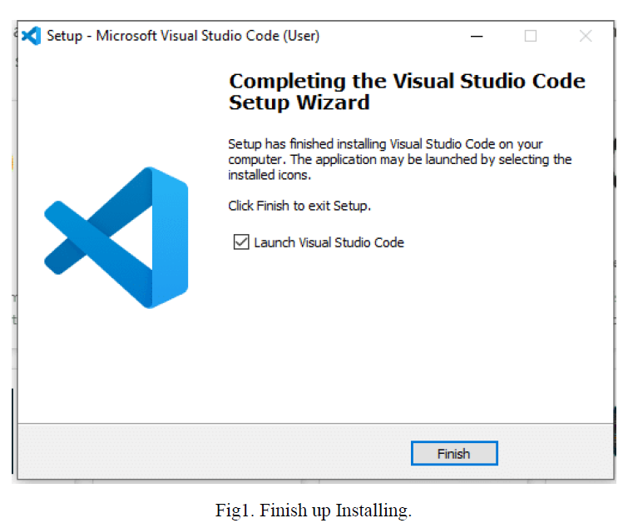

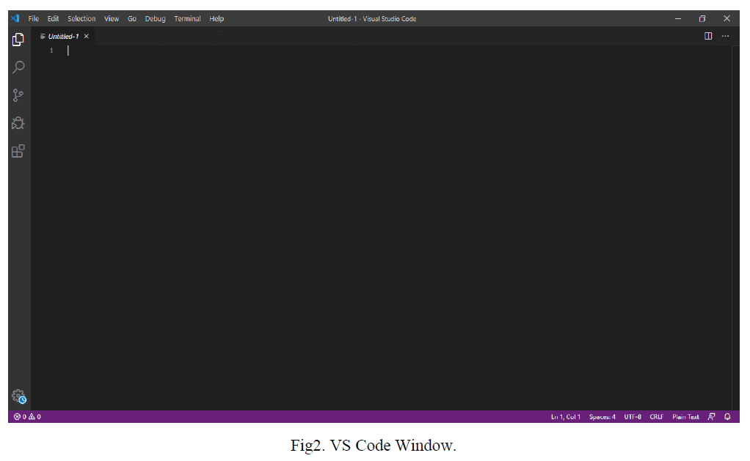

**2.4. Specific Requirements**

**2.4.1 Languages Used**

**HTML:**

**HTML** stands for **Hyper Text Mark-up Language**, which is the most widely used language on Web to develop web pages. HTML was created by Berners-Lee in late 1991 but "HTML 2.0" was the first standard HTML specification which was published in 1995. HTML 4.01 was a major version of HTML and it was published in late 1999. Though

HTML 4.01 version is widely used but currently we are having HTML-5 version which is an extension to HTML 4.01, and this version was published in 2012.

I will list down some of the key advantages of learning HTML:

• **Create Web site** - You can create a website or customize an existing web template if you know HTML well.

• **Become a web designer** - If you want to start a carrer as a professional web designer, HTML and CSS designing is a must skill.

• **Understand web** - If you want to optimize your website, to boost its speed and performance, it is good to know HTML to yield best results.

• **Learn other languages** - Once you understands the basic of HTML then other related technologies like java script, php, or angular are become easier to understand.

**CSS:**

Cascading **S**tyle **S**heets, fondly referred to as CSS, is a simple design language intended to simplify the process of making web pages presentable. CSS handles the look and feel part of

a web page. Using CSS, you can control the colour of the text, the style of fonts, the spacing between paragraphs, how columns are sized and laid out, what background images or colors are used, layout designs, variations in display for different devices and screen sizes as well as a variety of other effects.

CSS is easy to learn and understand but it provides powerful control over the presentation of an HTML document. Most commonly, CSS is combined with the mark-up languages HTML or XHTML.

• **CSS saves time** − You can write CSS once and then reuse same sheet in multiple HTML pages. You can define a style for each HTML element and apply it to as many Web pages as you want.

• **Pages load faster** − If you are using CSS, you do not need to write HTML tag attributes every time. Just write one CSS rule of a tag and apply it to all the occurrences of that tag. So less code means faster download times.

• **Easy maintenance** − To make a global change, simply change the style, and all elements in all the web pages will be updated automatically.

• **Superior styles to HTML** − CSS has a much wider array of attributes than HTML, so you can give a far better look to your HTML page in comparison to HTML attributes.

• **Multiple Device Compatibility** − Style sheets allow content to be optimized for more than one type of device. By using the same HTML document, different versions of a website can be presented for handheld devices such as PDAs and cell phones or for printing.

**JavaScript:**

**JavaScript** is a lightweight, interpreted programming language. It is designed for creating network-centric applications. It is complimentary to and integrated with Java. JavaScript is very easy to implement because it is integrated with HTML. It is open and cross-platform.

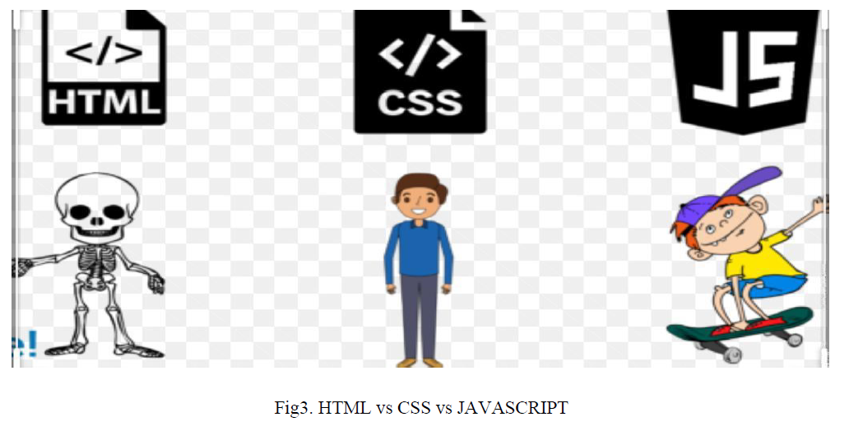

**Chapter-3**

**Software Designs**

**3.1 Use Case diagram**

A **use case diagram** is a dynamic or behaviour diagram in UML. Use case diagrams model the functionality of a system using actors and use cases. Use cases are a set of actions, services, and functions that the system needs to perform.

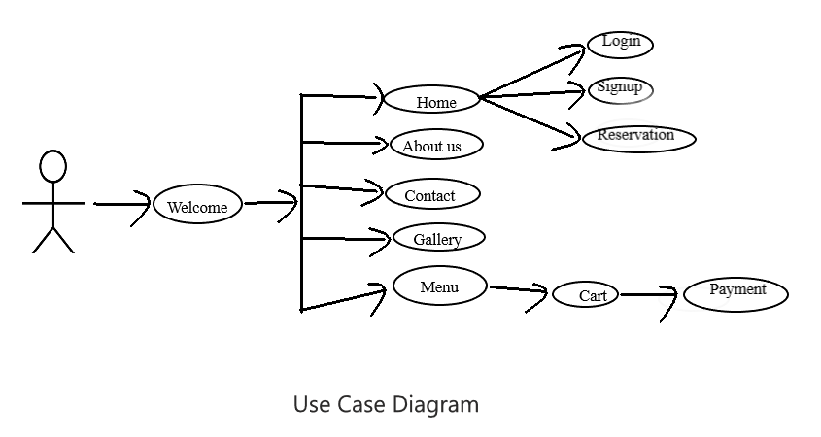

**3.2 Data Flow Diagram**

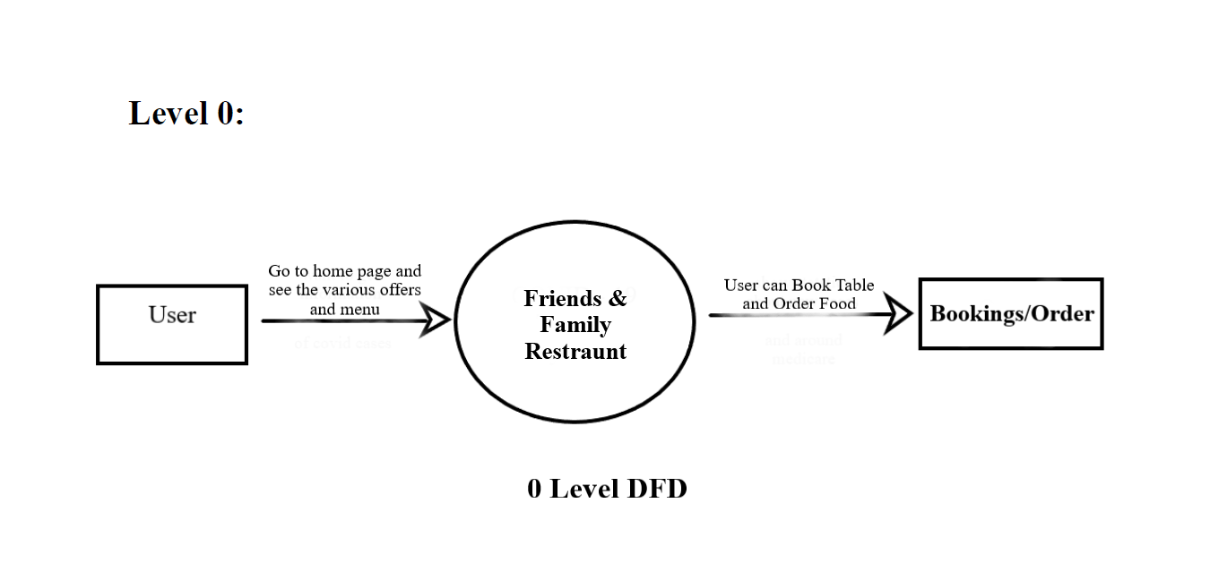

**Level 1 DFD:**

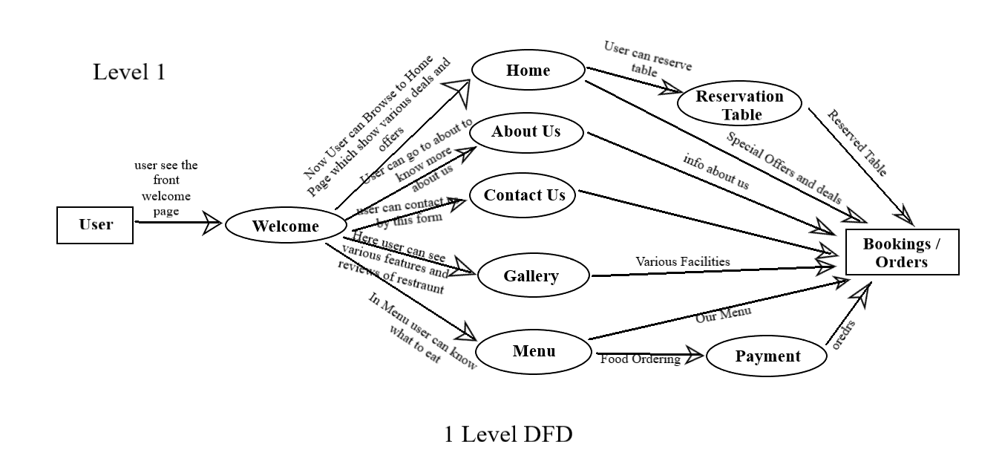

**Chapter-4**

**Testing**

**4.1 Introduction**

The implementation phase of software development is concerned with translating design specification into source code. The preliminary goal of implementation is to write source code and internal documentation so that conformance of the code to its specifications can be easily verified, and so that debugging, testing and modifications are eased. This goal can be achieved by making the source code as clear and straightforward as possible. Simplicity, clarity and elegance are the hallmark of good programs, obscurity, cleverness, and complexity are indications of inadequate design and misdirected thinking.

Source code clarity is enhanced by structured coding techniques, by good coding style, by, appropriate supporting documents, by good internal comments, and by feature provided in modern programming languages. The implementation team should be provided with a well-defined set of software requirement, an architectural design specification, and a detailed design description. Each team member must understand the objectives of implementation.

**4.2. Error**

The term error is used in two ways. It refers to the difference between the actual output of software and the correct output, in this interpretation, error is essential a measure of the difference between actual and ideal. Error is also to used to refer to human action that result in software containing a defect or fault.

**4.3. Fault**

Fault is a condition that causes to fail in performing its required function. A fault is a basic reason for software malfunction and is synonymous with the commonly used term Bug.

**4.4. Failure**

Failure is the inability of a system or component to perform a required function according to its specifications. A software failure occurs if the behaviour of the software is the different from the specified behaviour. Failure may be caused due to functional or performance reasons.

**a. Unit Testing**

The term unit testing comprises the sets of tests performed by an individual programmer prior to integration of the unit into a larger system.

A program unit is usually small enough that the programmer who developed it can test it in great detail, and certainly in greater detail than will be possible when the unit is integrated into an evolving software product. In the unit testing the programs are tested separately, independent of each other. Since the check is done at the program level, it is also called program teasing.

**b. Module Testing**

A module and encapsulates related component. So can be tested without other system module.

**c. Subsystem Testing**

Subsystem testing may be independently design and implemented common problems are sub-system interface mistake in this checking we concenton it. There are four categories of tests that a programmer will typically perform on a program unit.

i Functional test

ii Performance test

iii Stress test

iv Structure test

**4.5 Functional Test**

Functional test cases involve exercising the code with Nominal input values for which expected results are known; as well as boundary values (minimum values, maximum values and values on and just outside the functional boundaries) and special values.

**4.6 Performance Test**

Performance testing determines the amount of execution time spent in various parts of the unit, program throughput, response time, and device utilization by the program unit. A certain amount of avoid expending too much effort on fine-tuning of a program unit that contributes little to the overall performance of the entire system. Performance testing is most productive at the subsystem and system levels.

**4.7 Stress Test**

Stress test are those designed to intentionally break the unit. A great deal can be learned about the strengths and limitations of a program by examining the manner in which a program unit breaks.

**4.8 Structure Test**

Structure tests are concerned with exercising the internal logic of a program and traversing particular execution paths. Some authors refer collectively to functional performance and stress testing as “black box” testing. While structure testing is referred to as “white box” or “glass box” testing. The major activities in structural testing are deciding which path to exercise, deriving test date to exercise those paths, determining the test coverage criterion to be used, executing the test, and measuring the test coverage achieved when the test cases are exercised.

**Chapter-5**

**Implementation and User Interface**

Welcome Page:

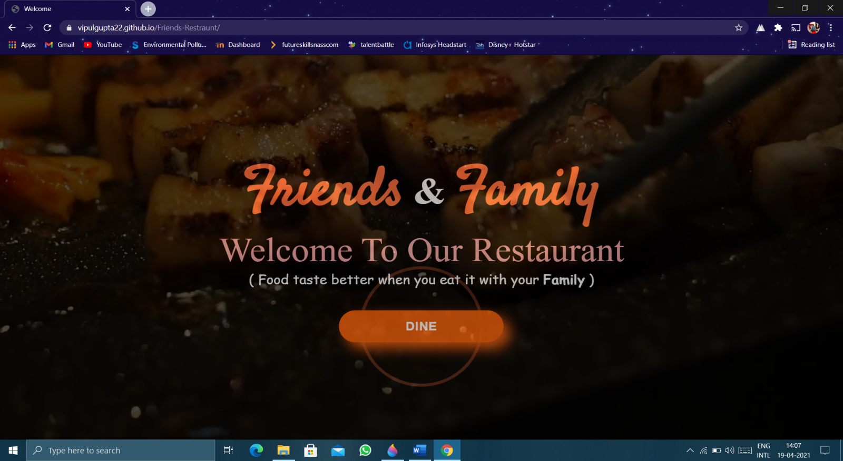

Home Page:

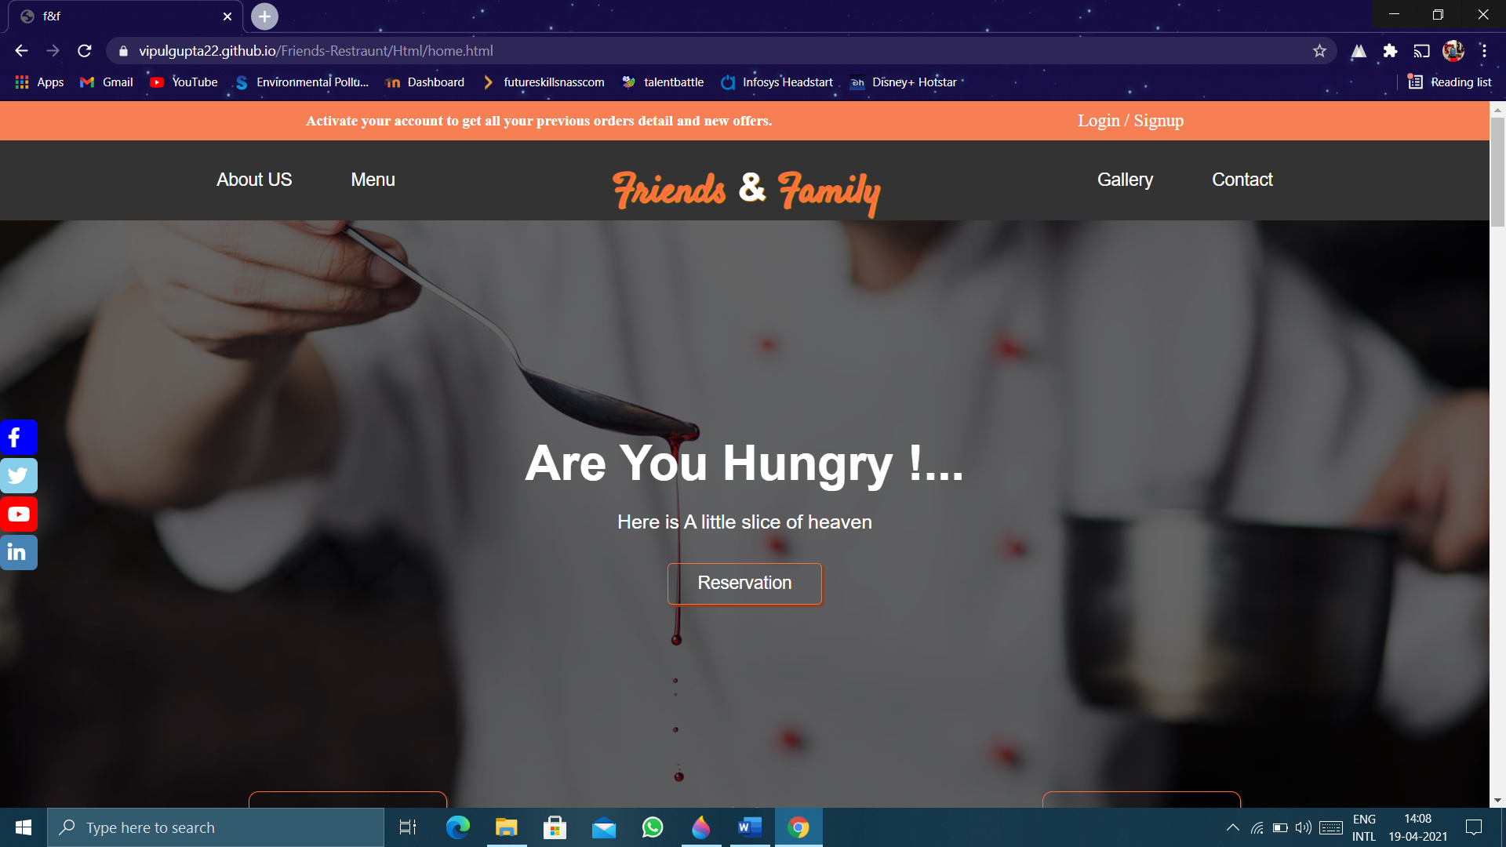

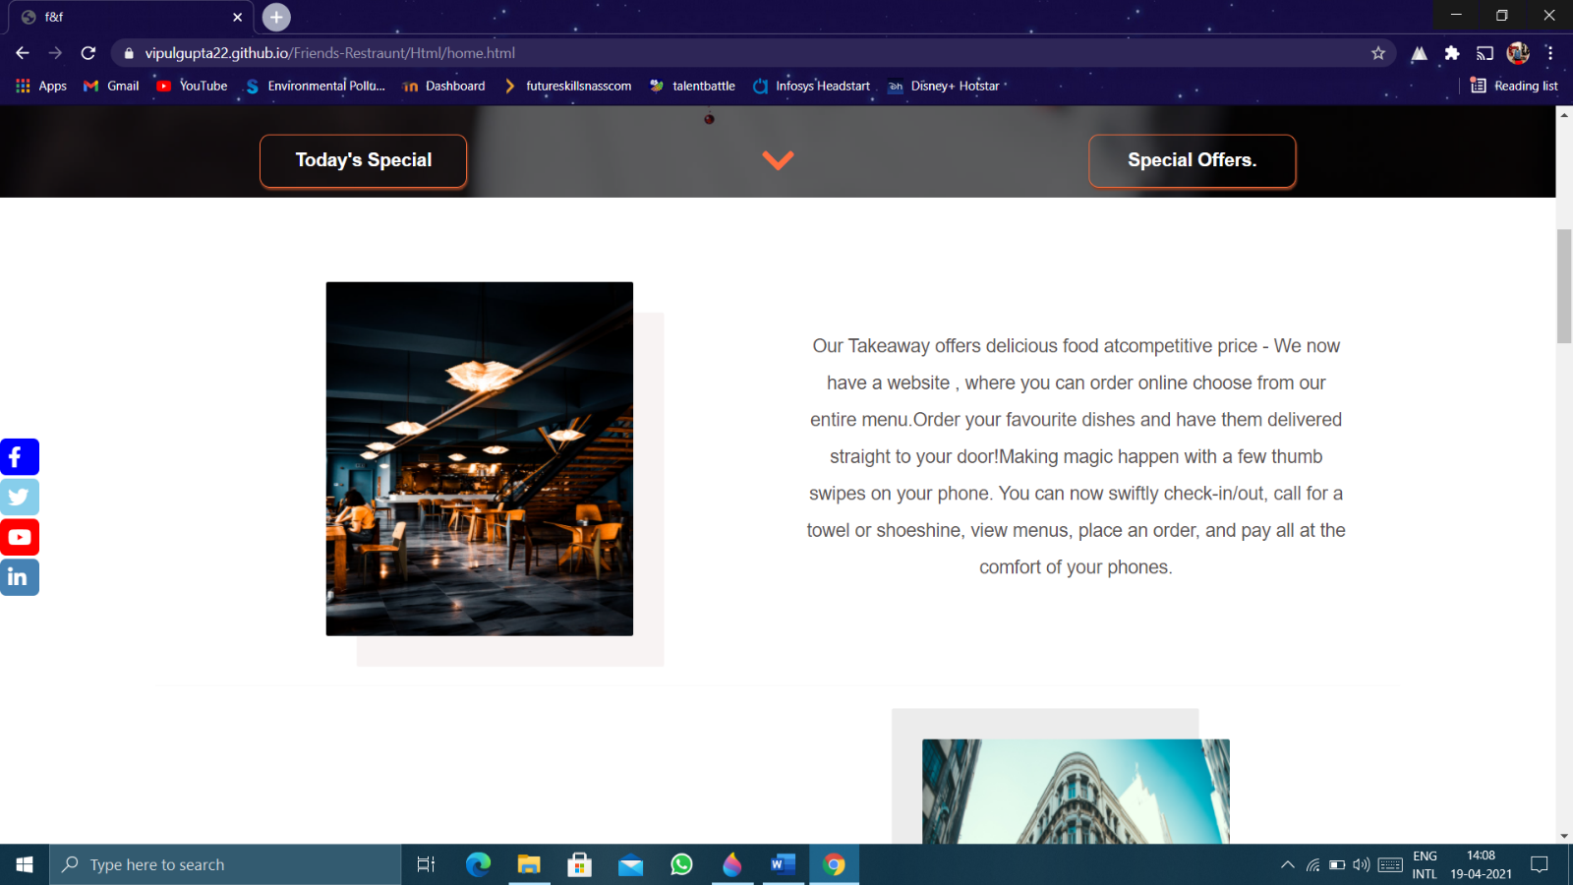

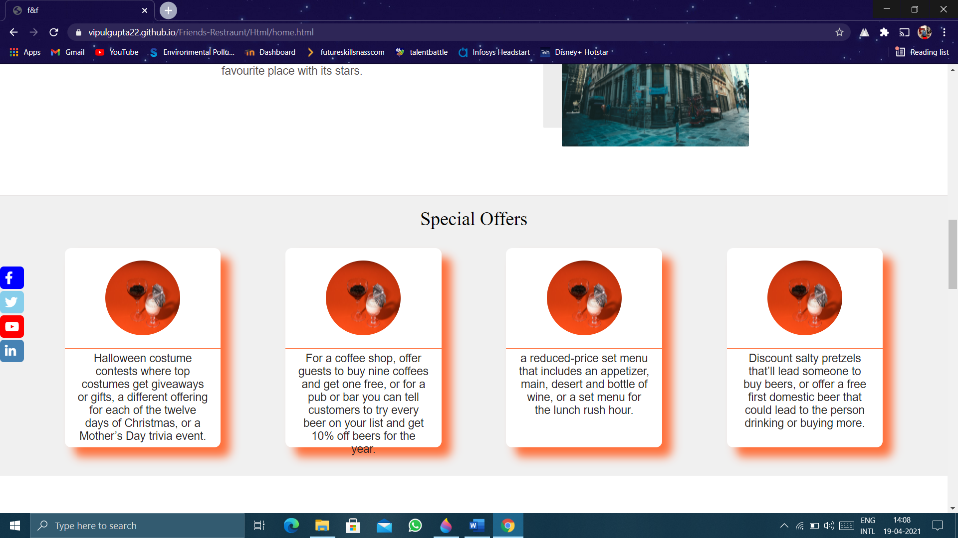

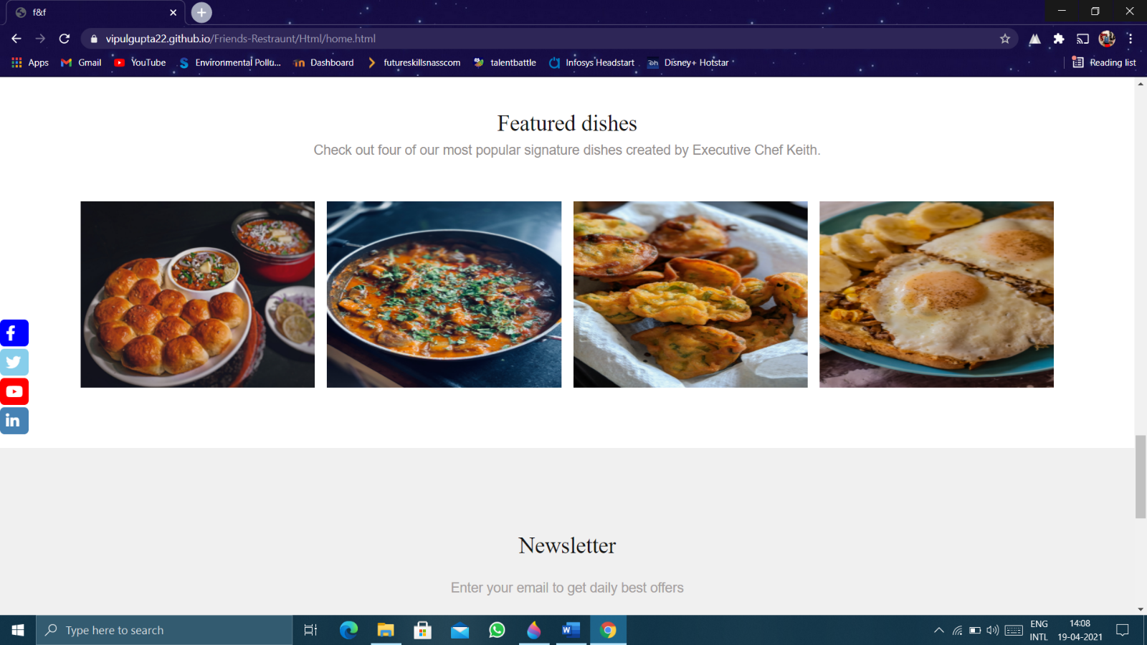

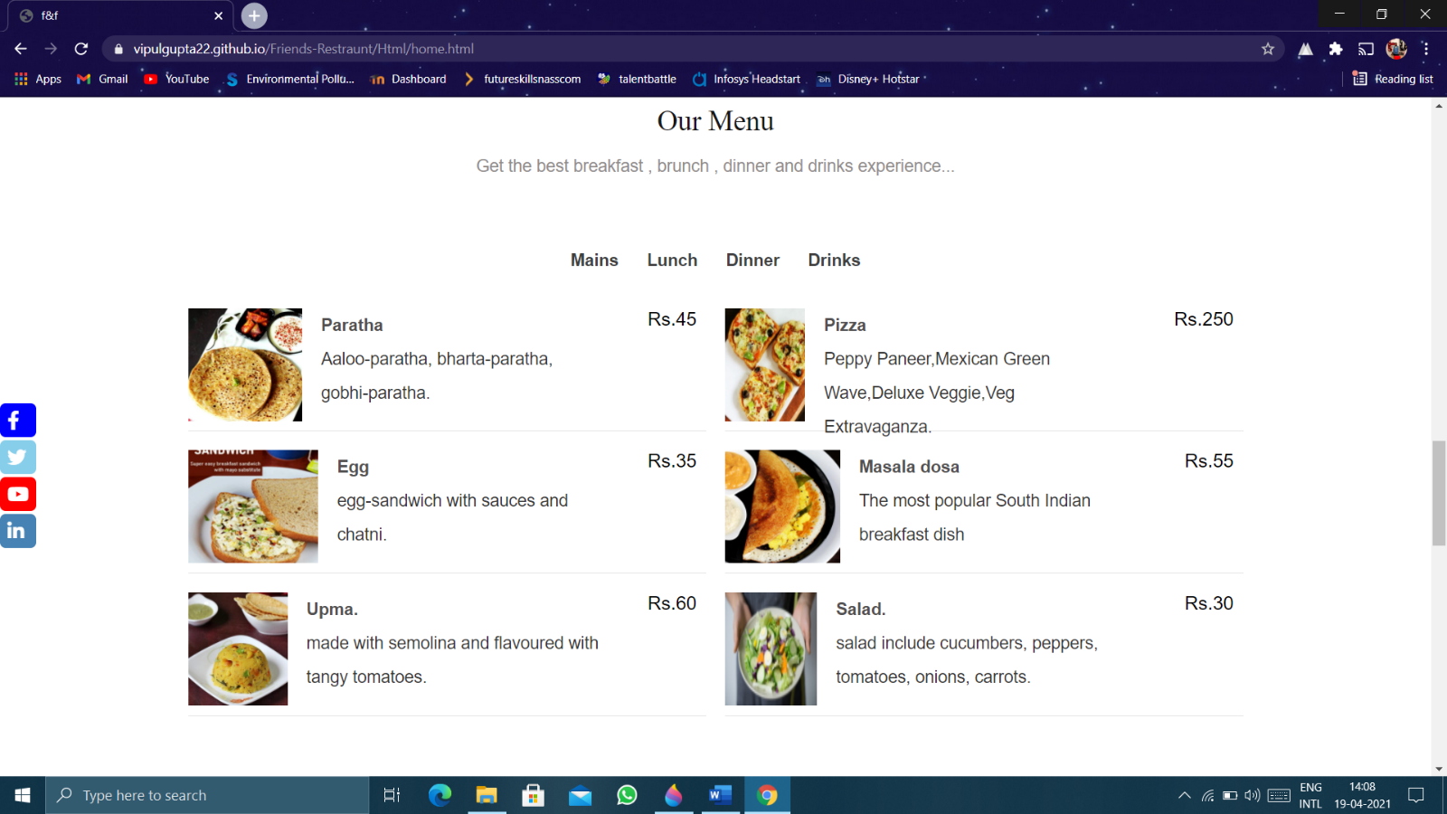

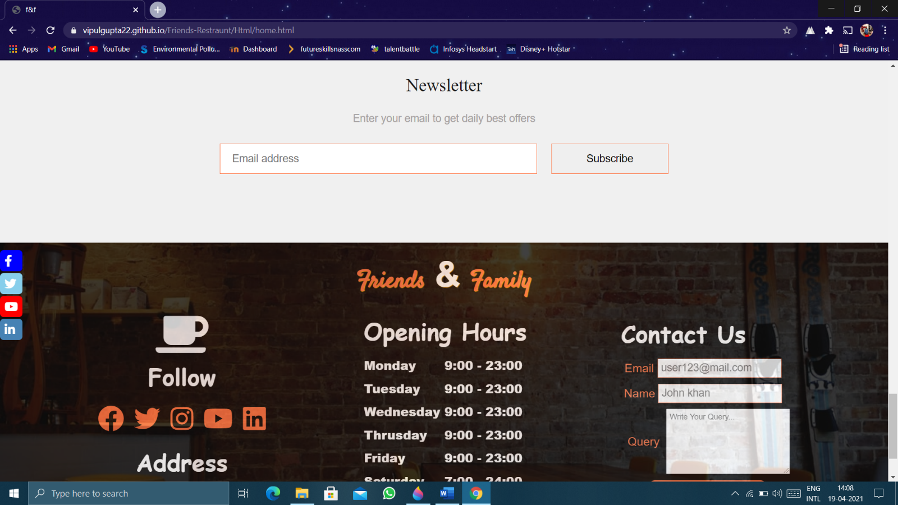

Table Reservation Page:

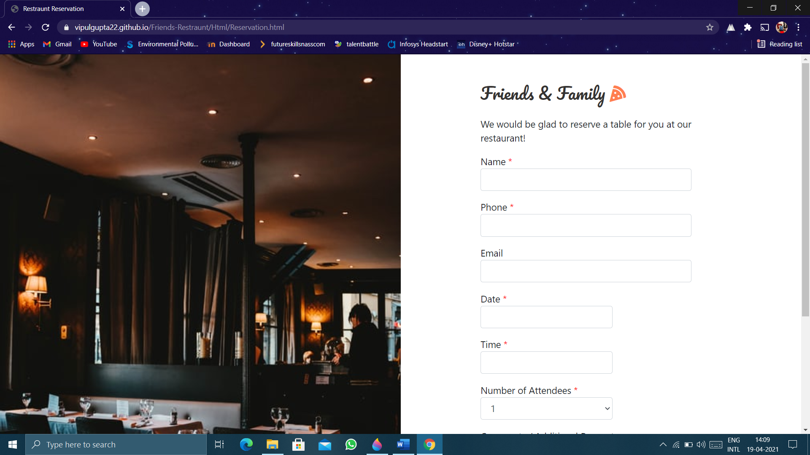

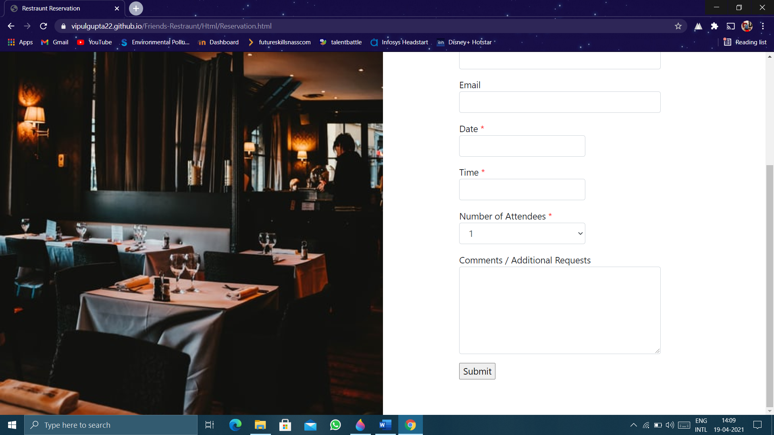

Login:

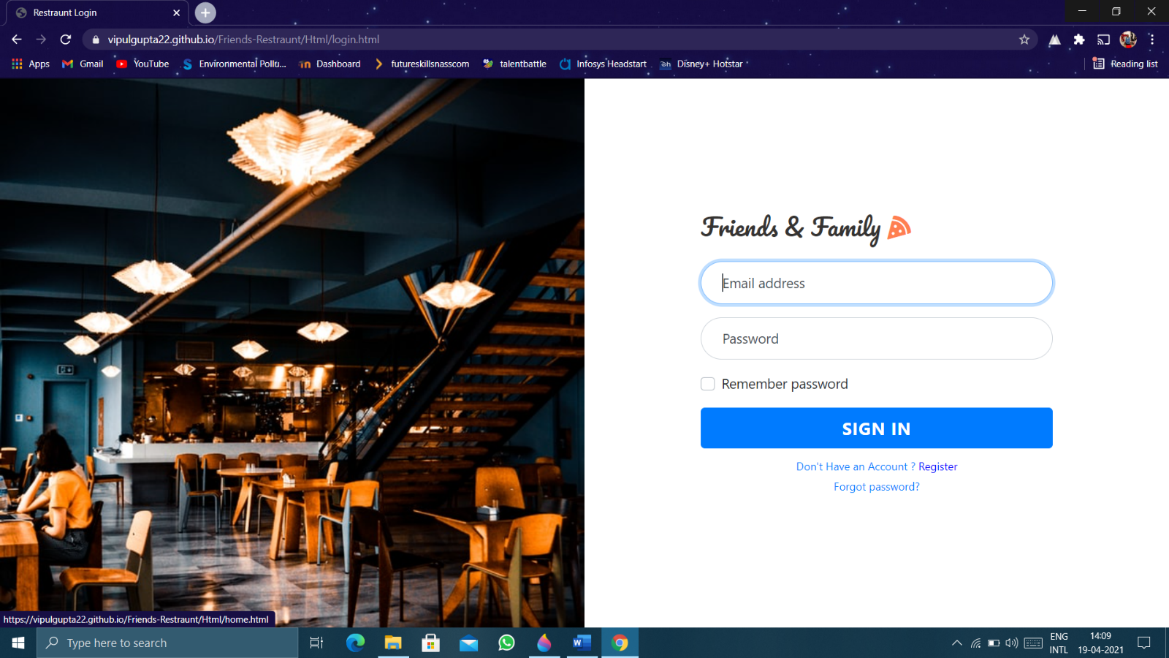

Signup:

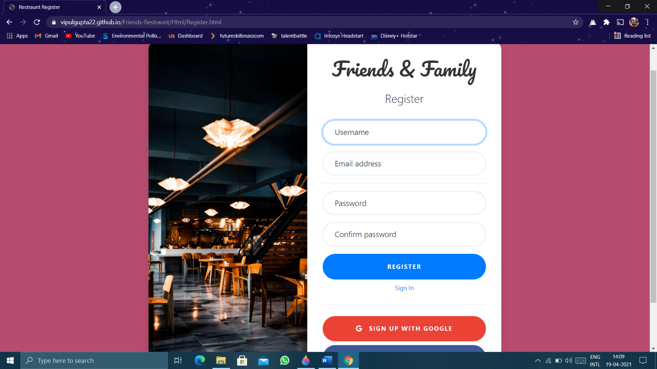

Forgot Password:

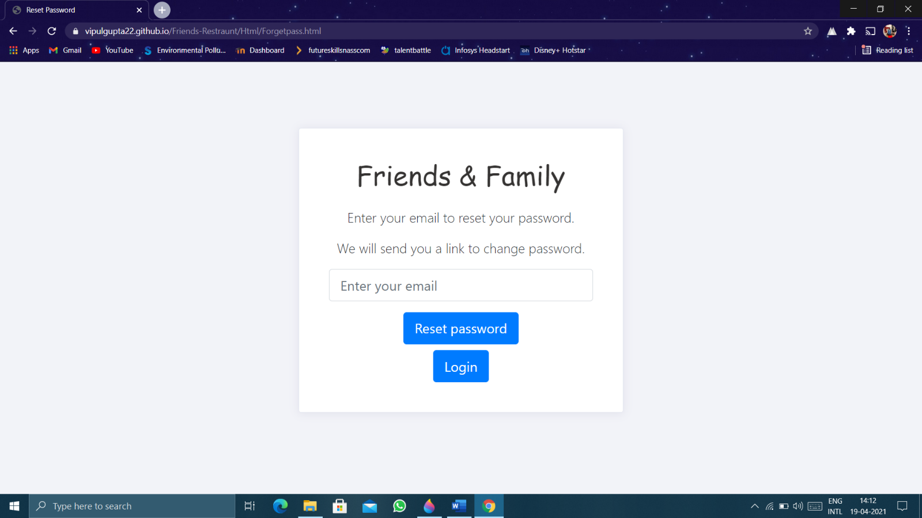

About Us:

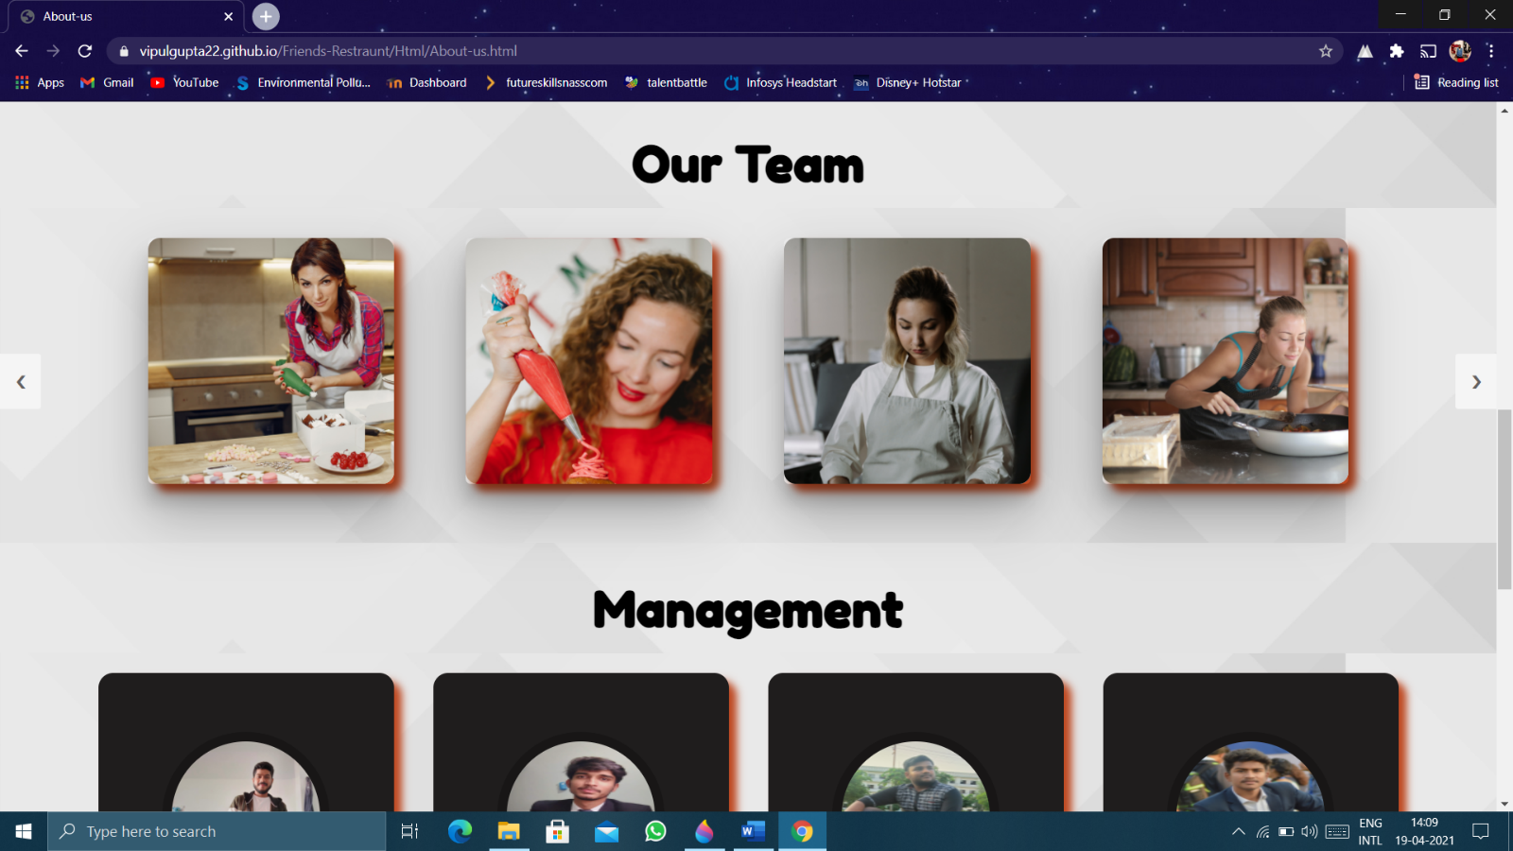

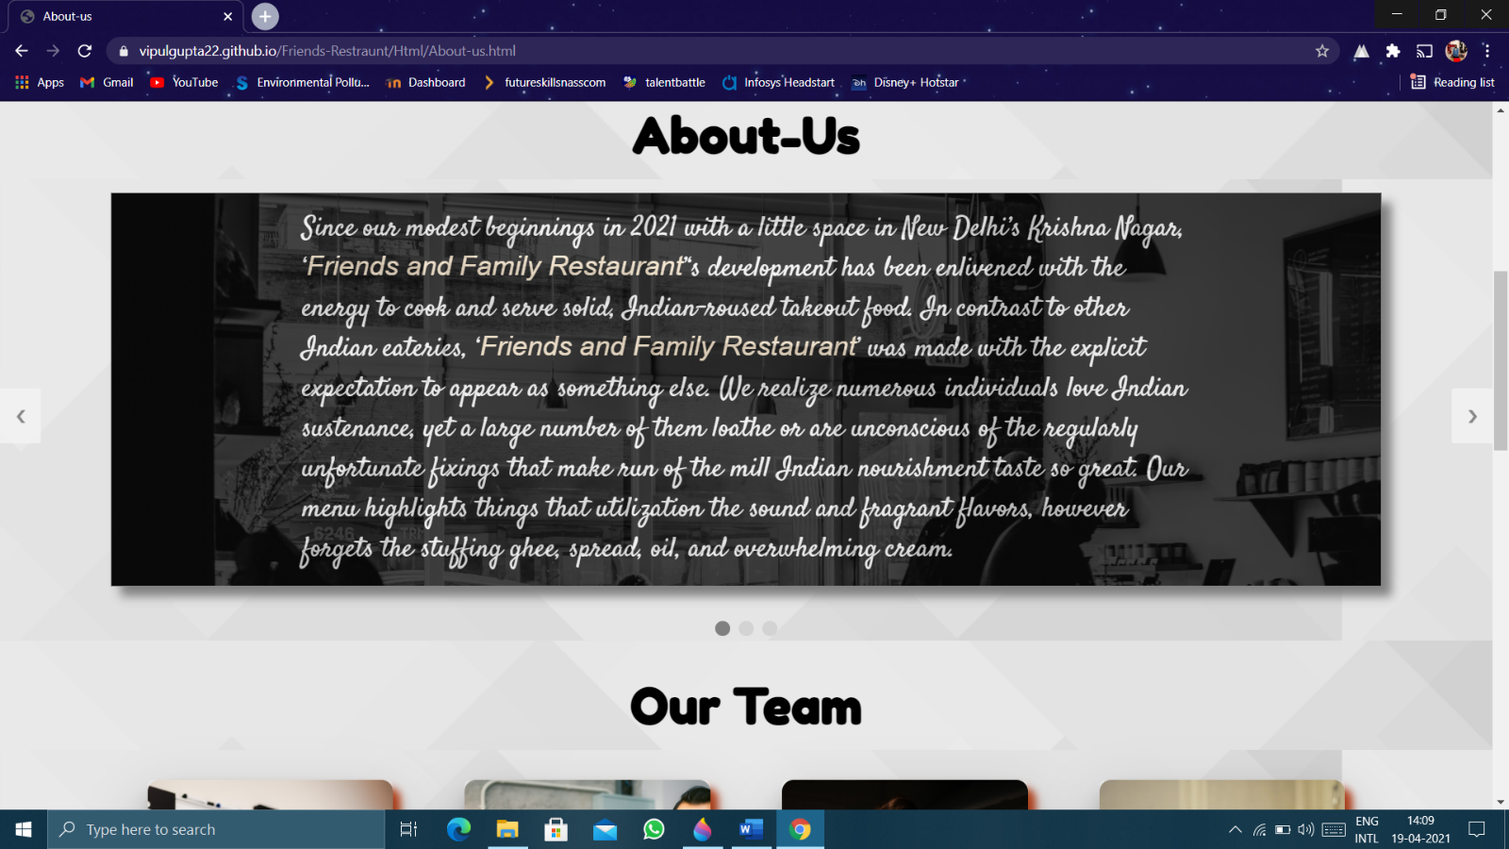

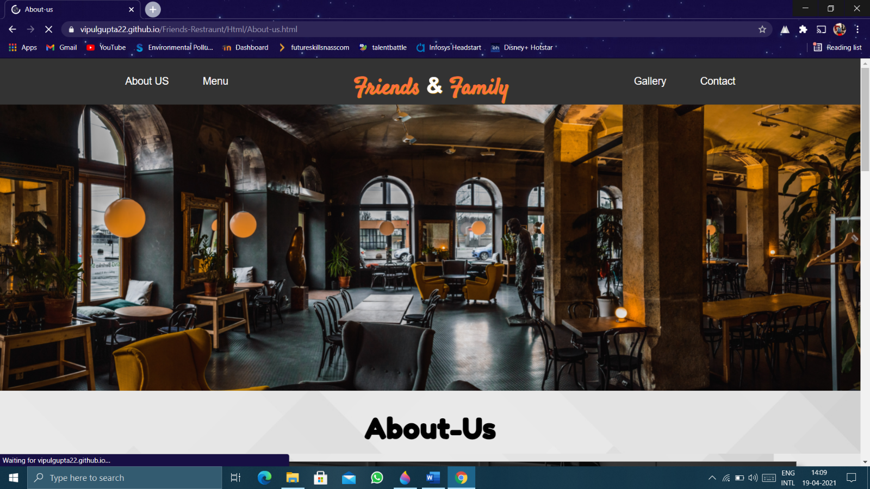

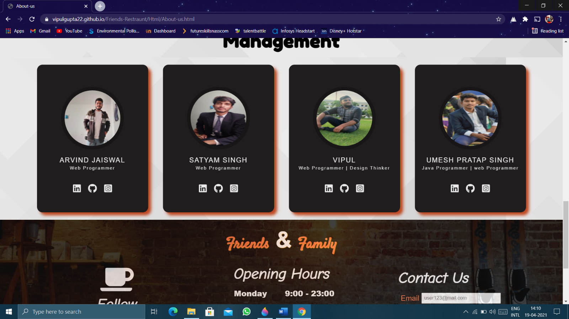

Gallery Page:

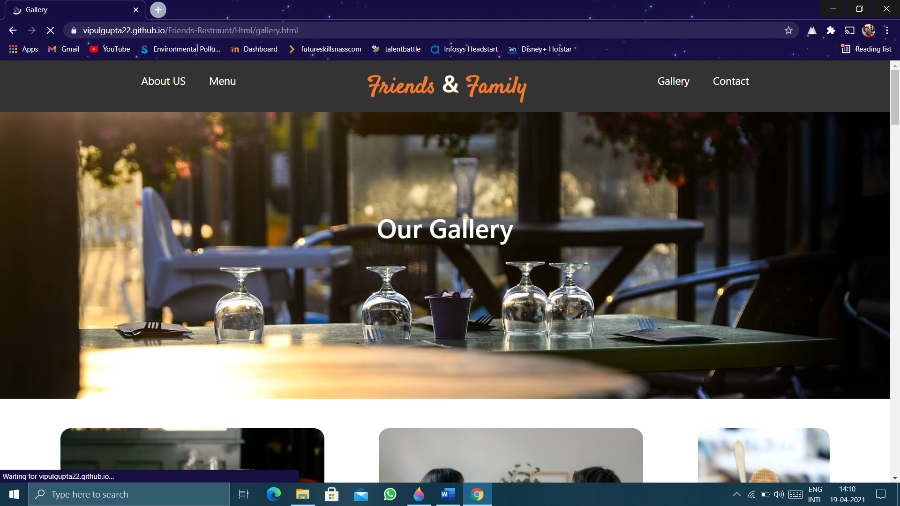

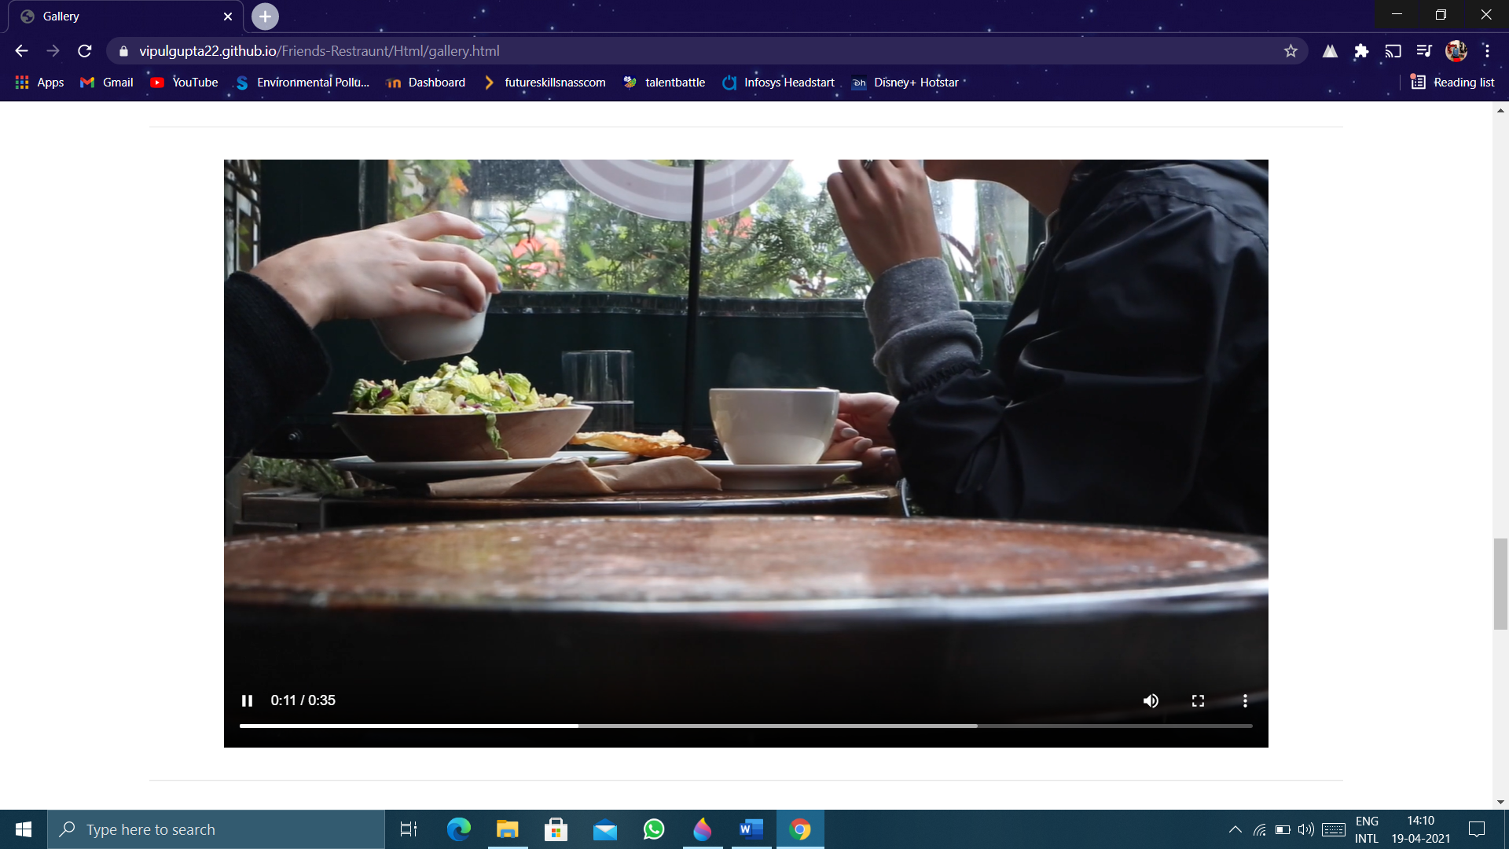

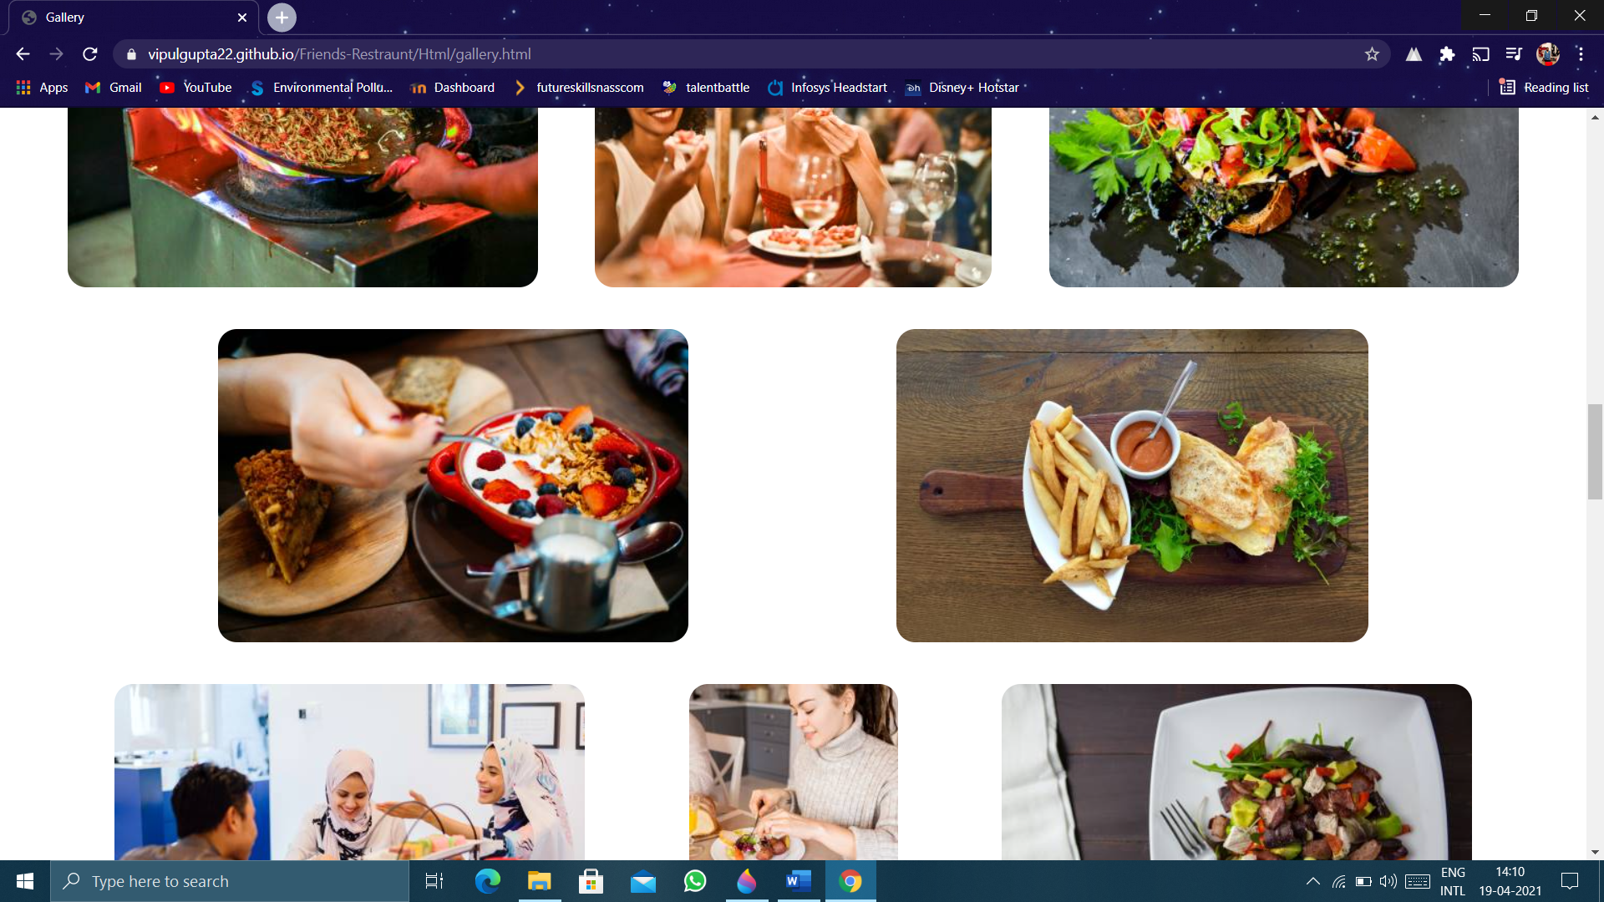

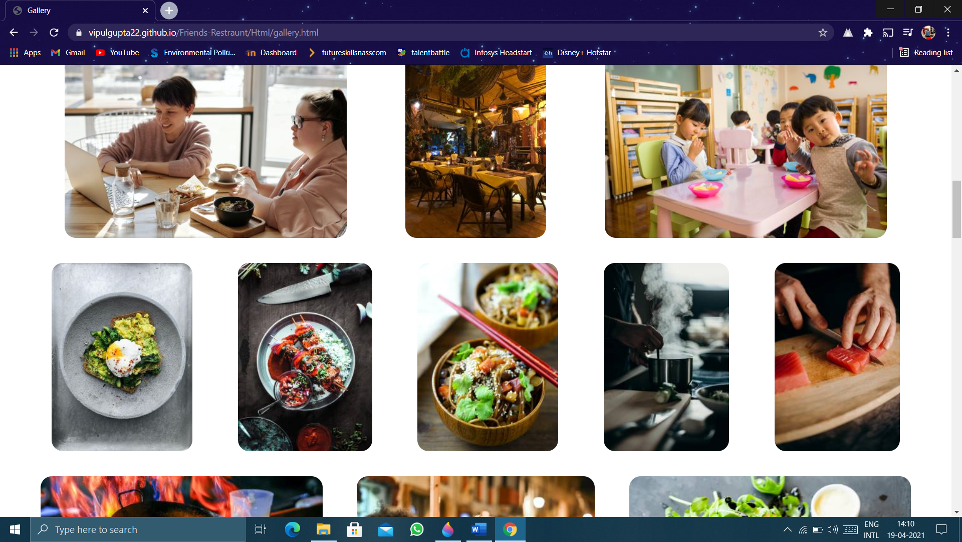

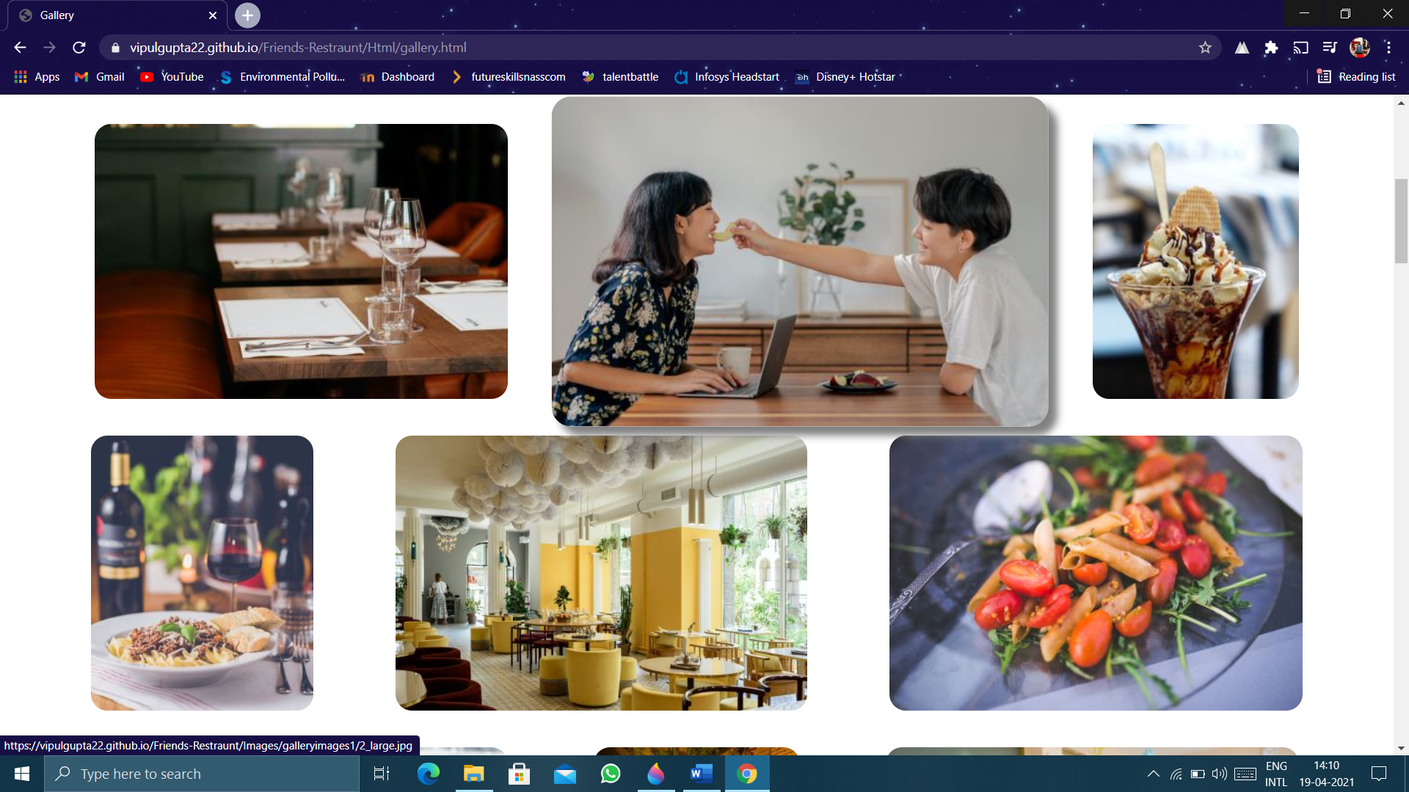

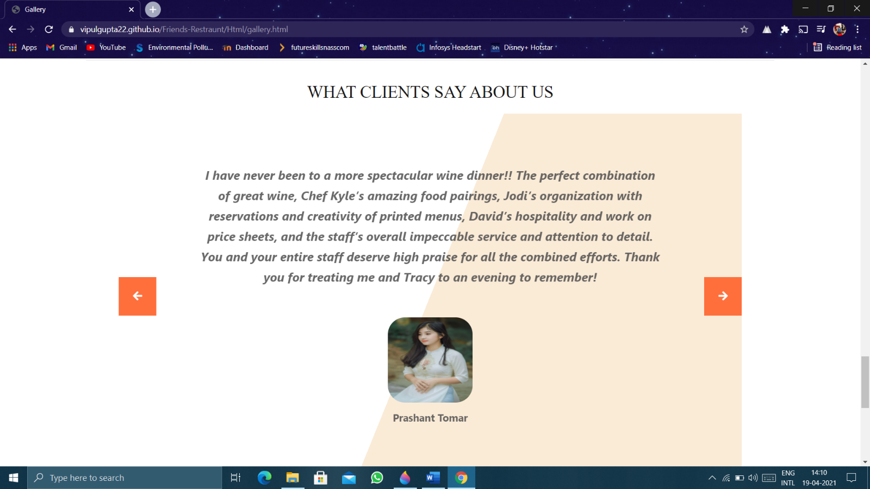

Contact Us:

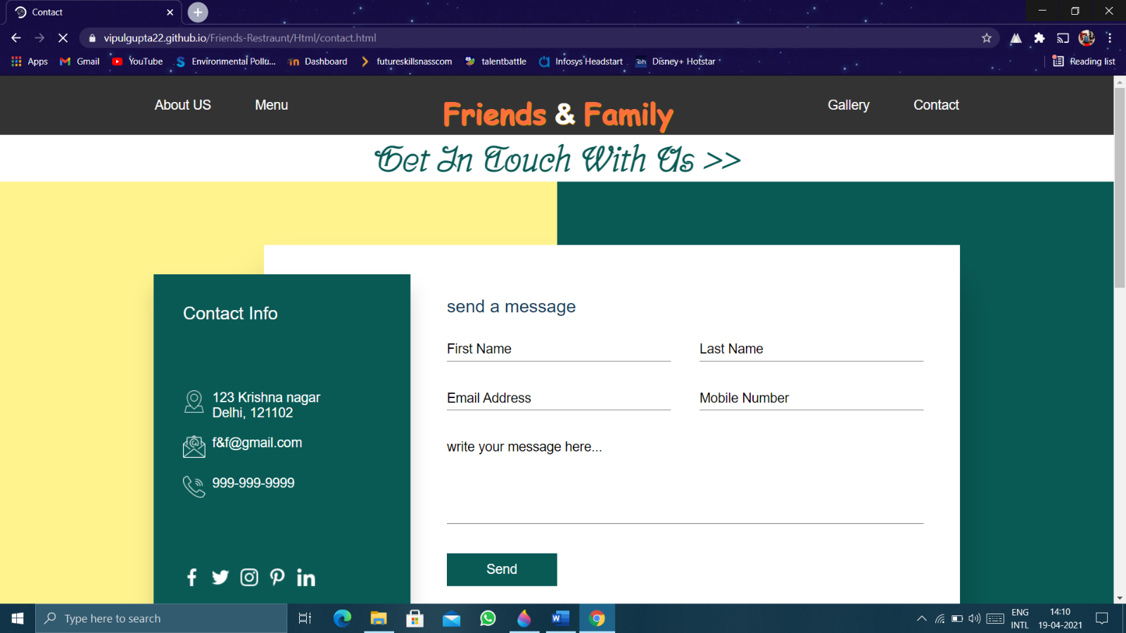

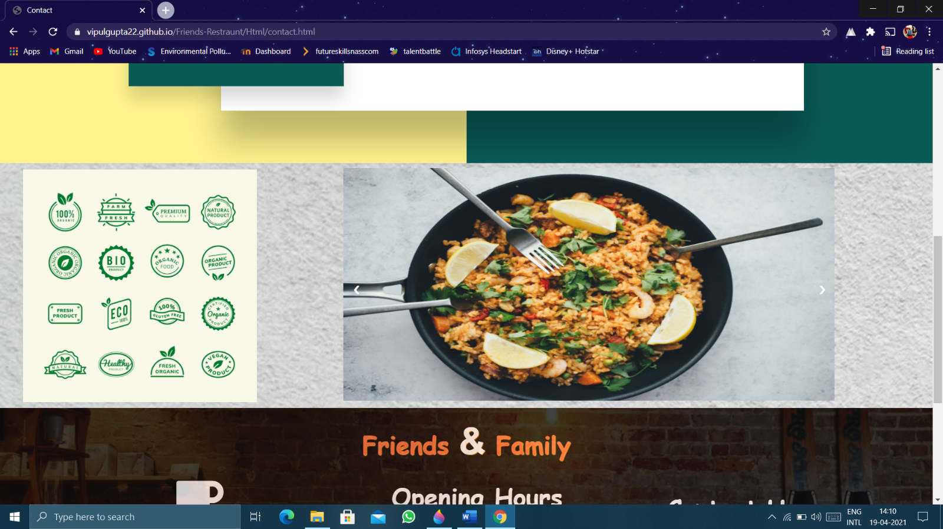

Menu Page:

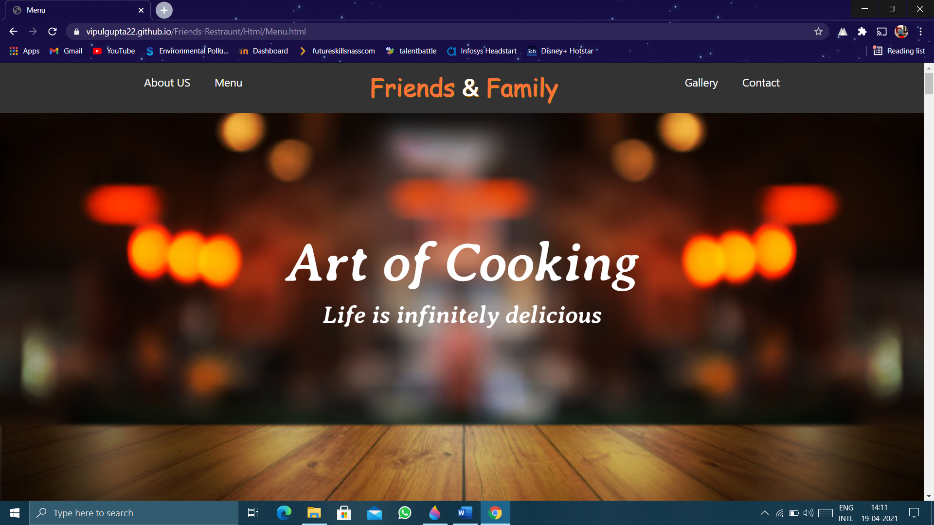

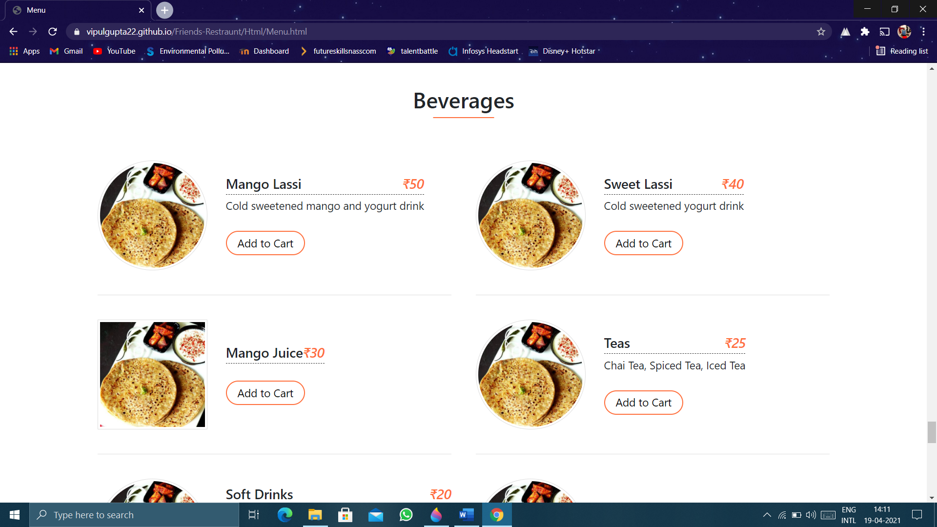

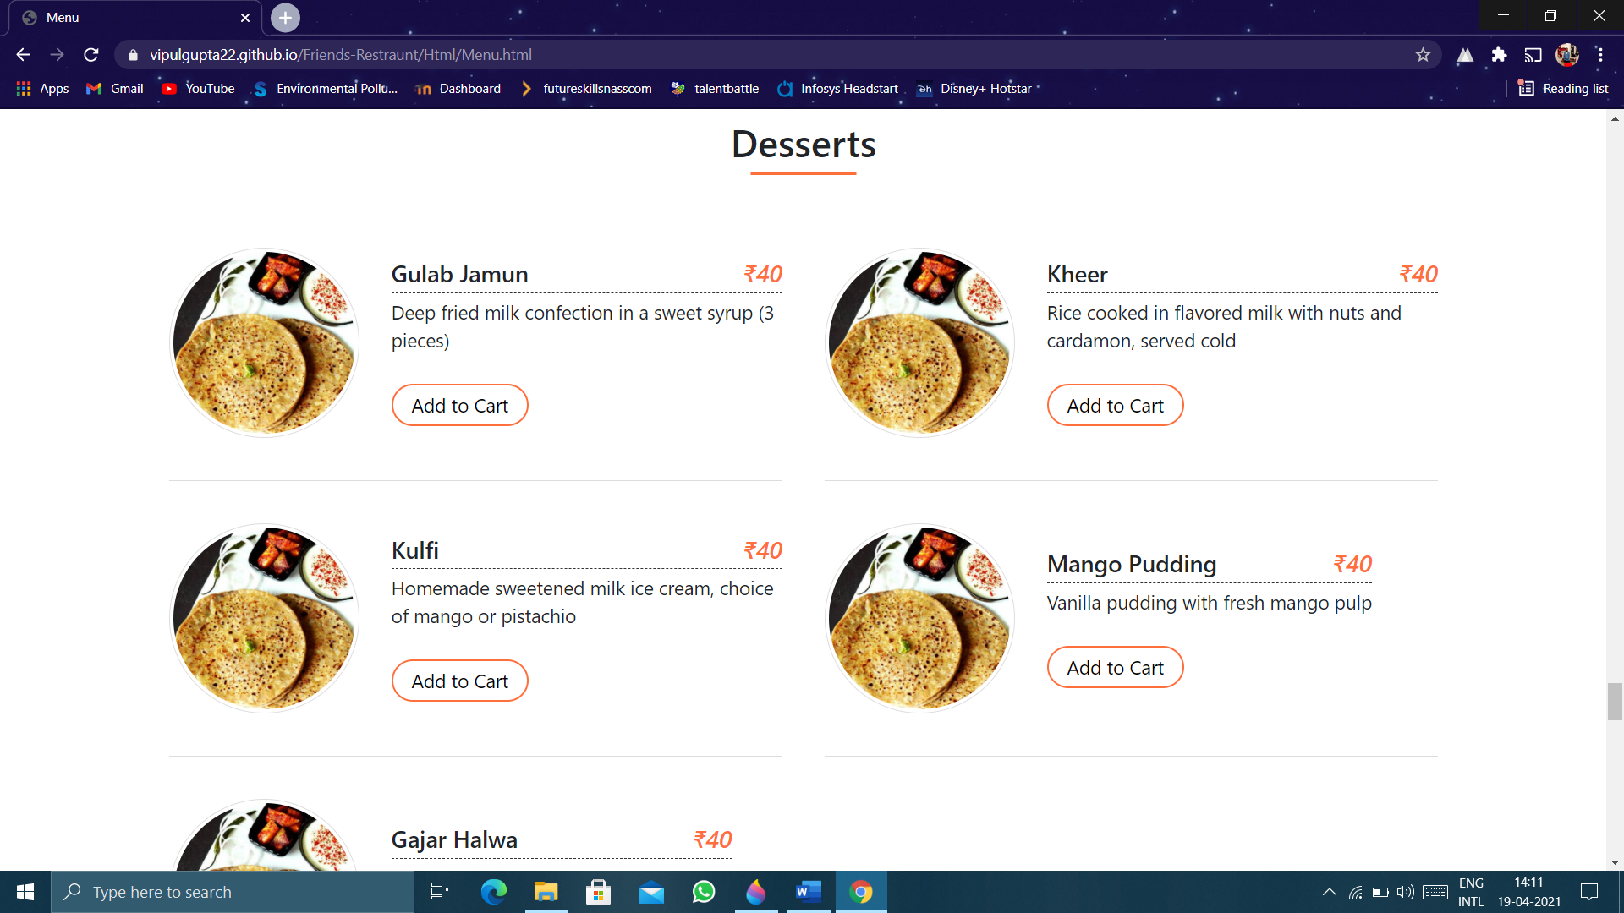

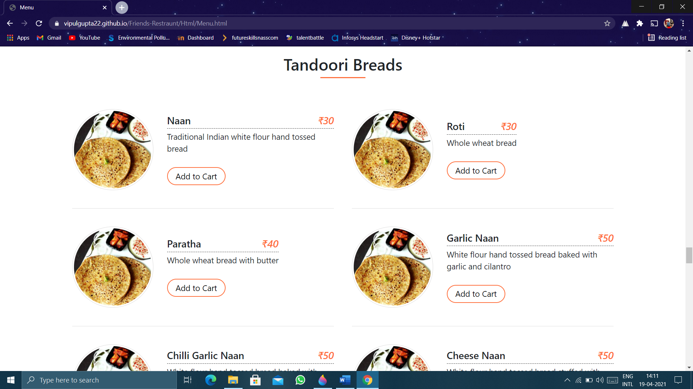

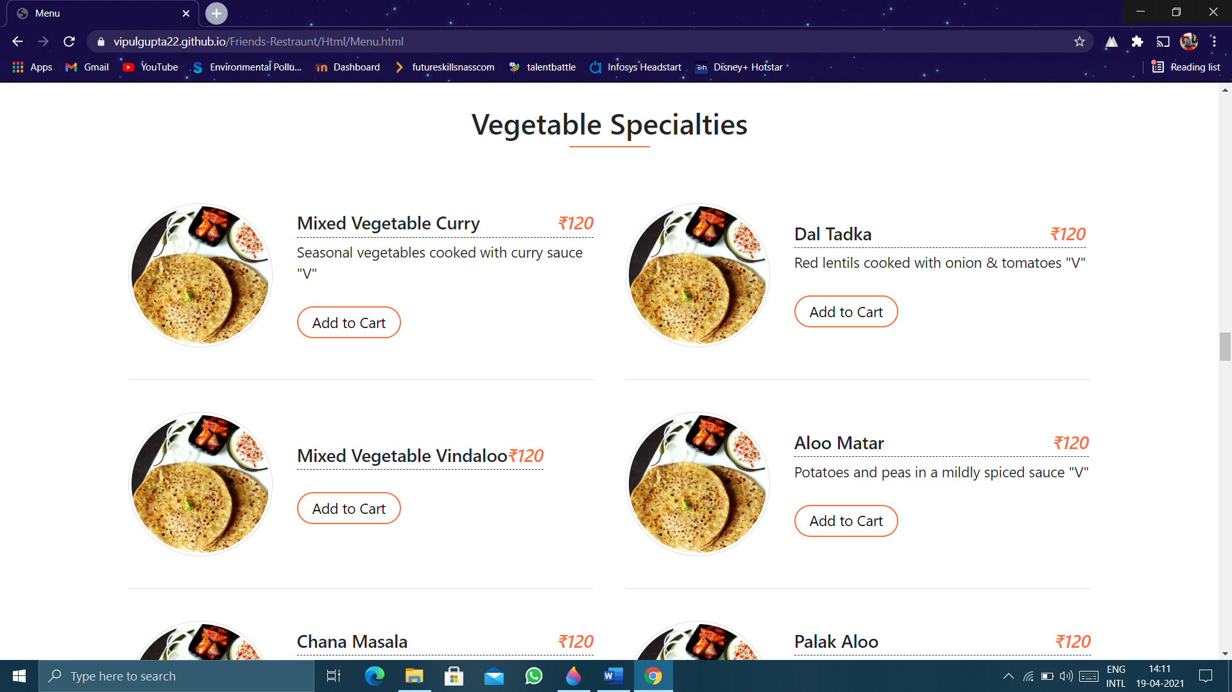

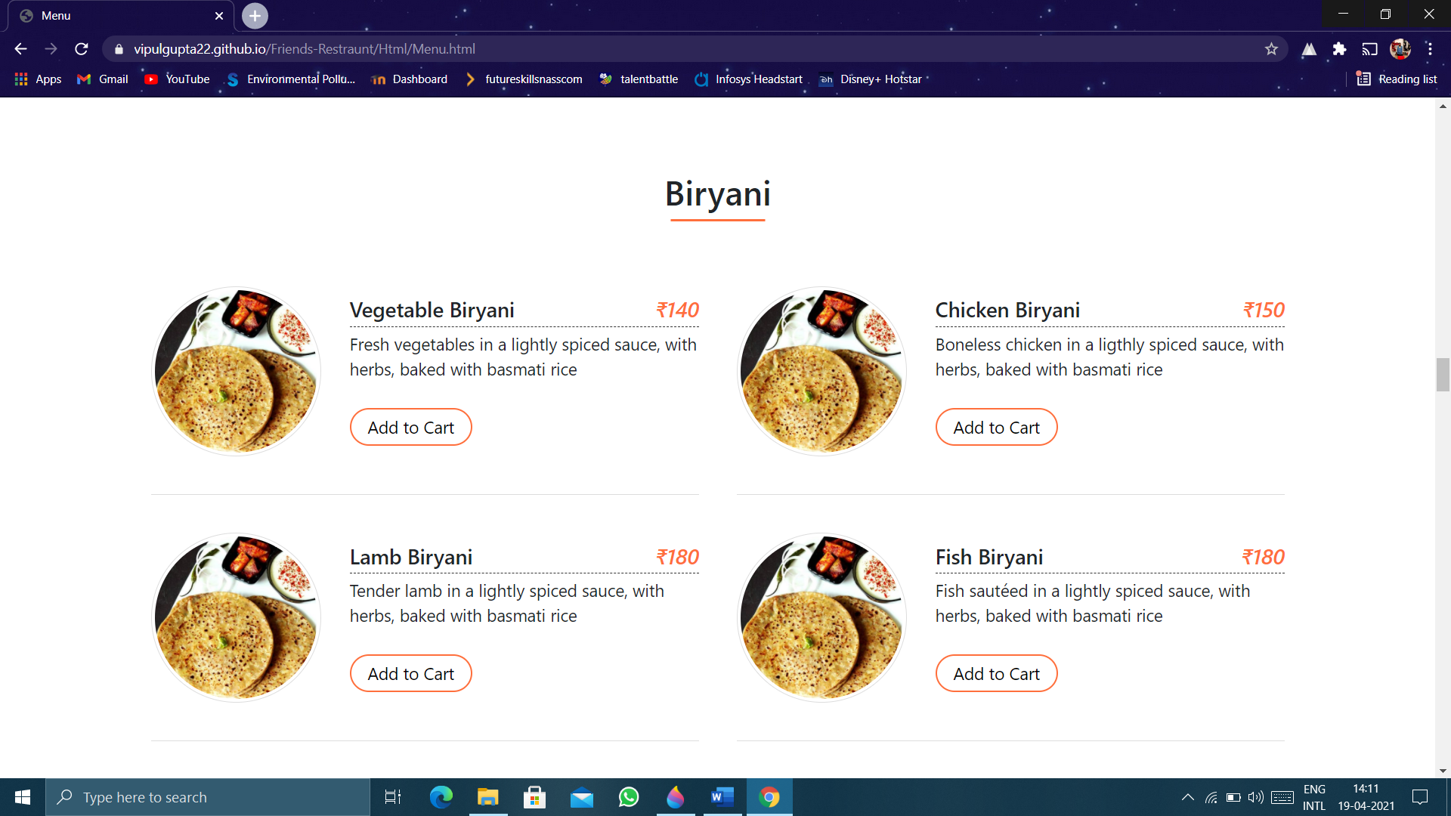

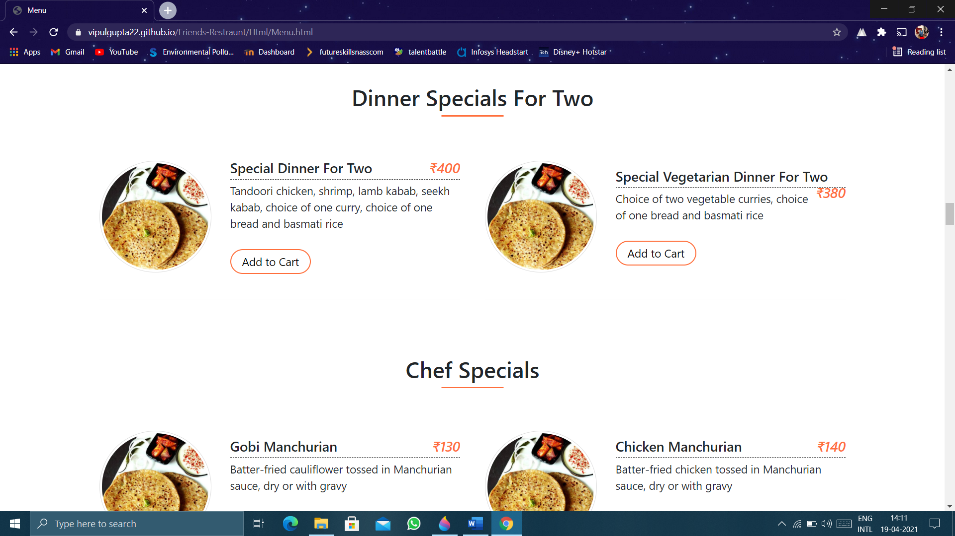

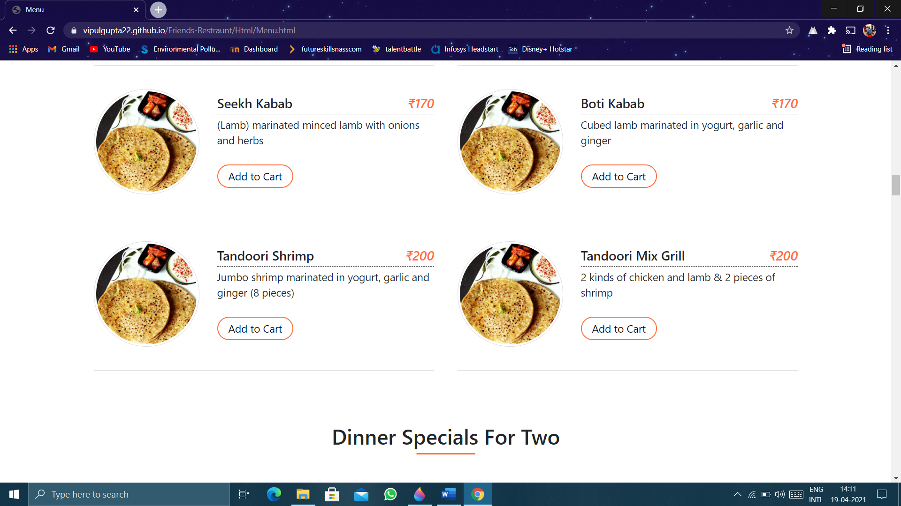

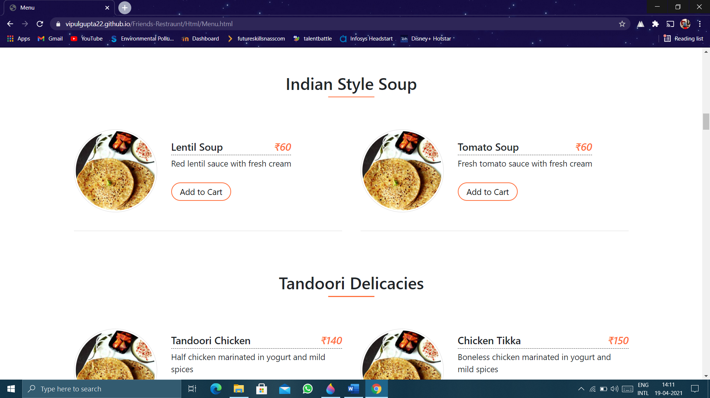

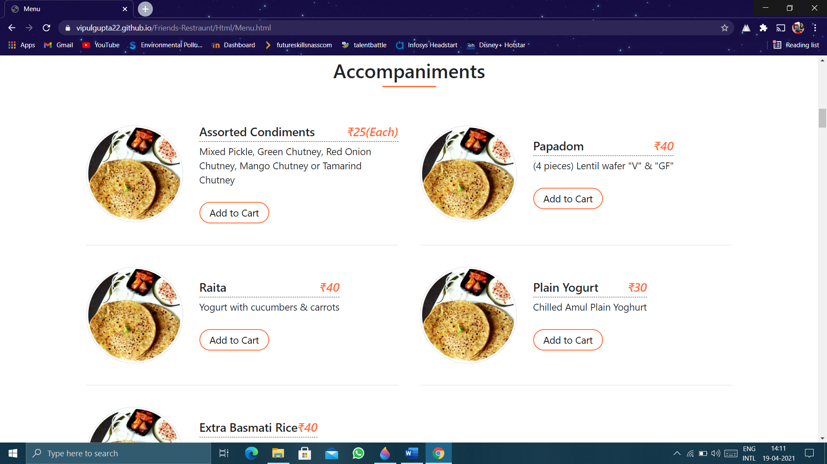

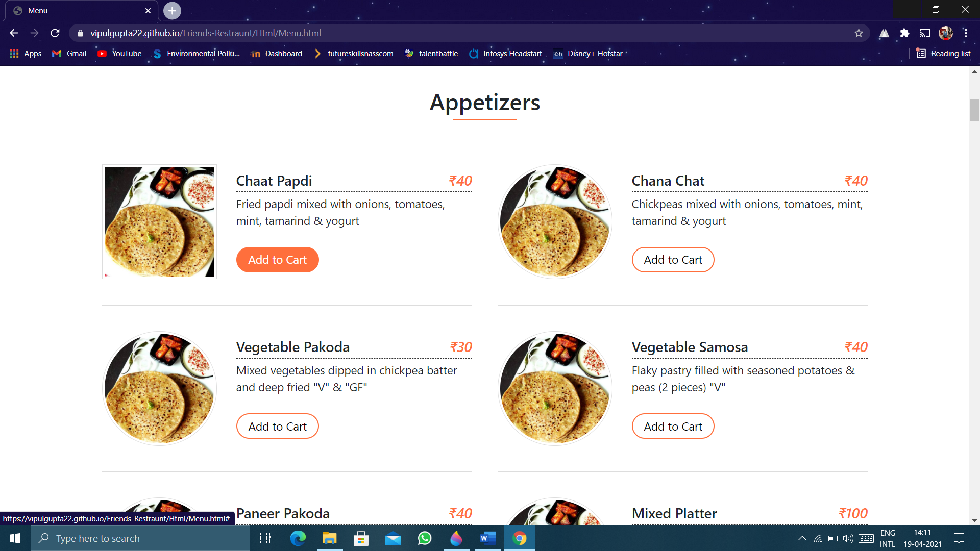

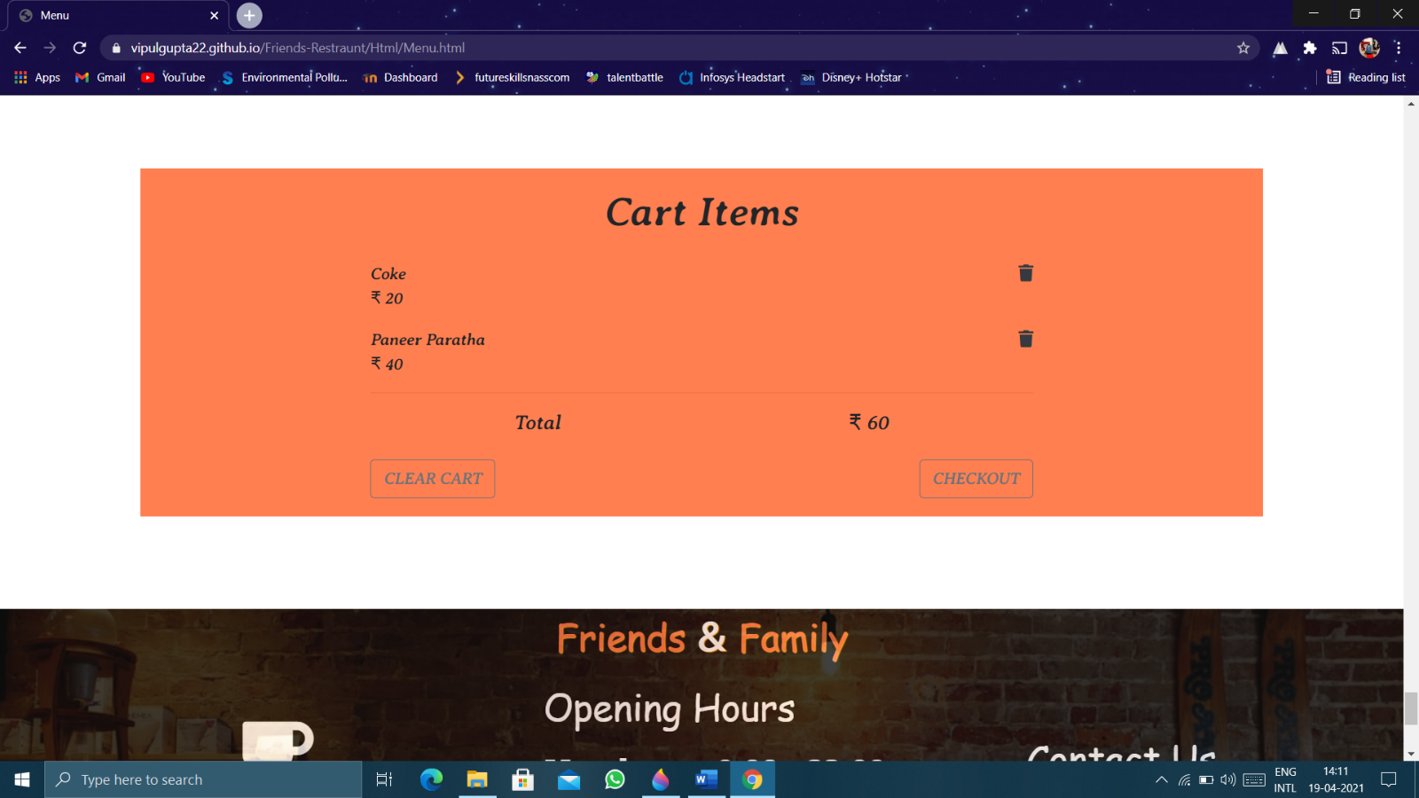

Checkout Page:

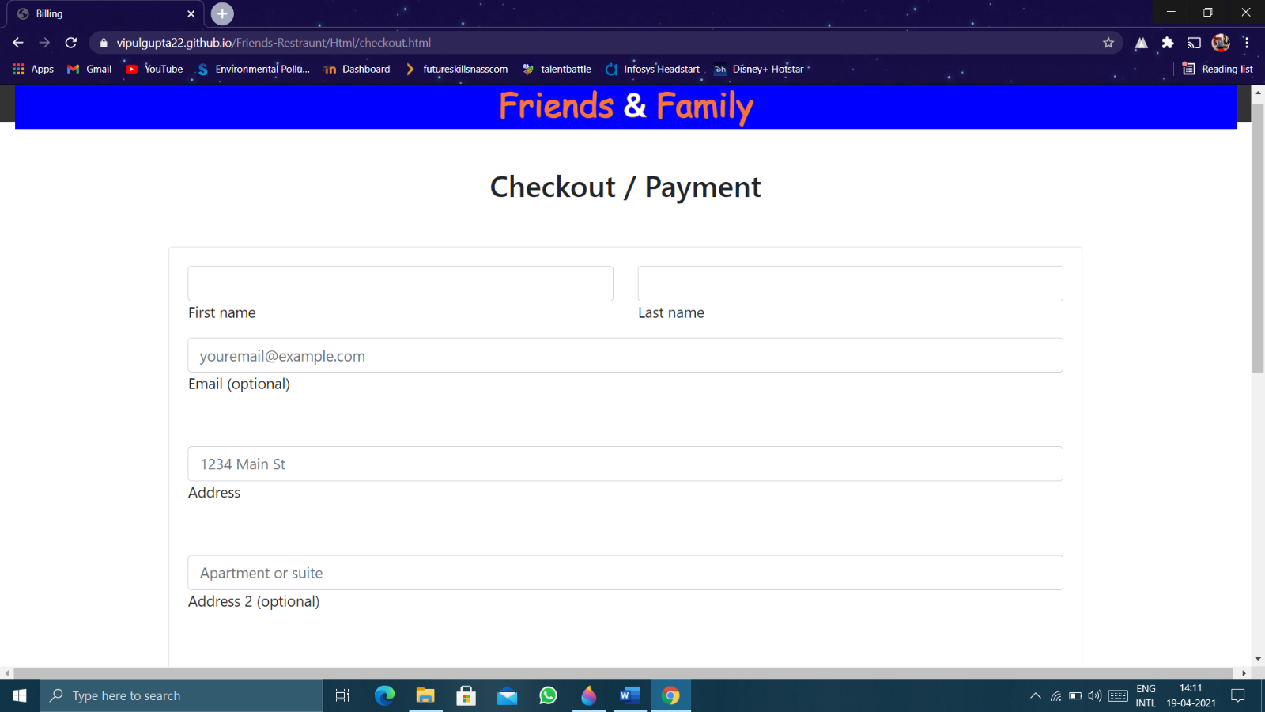

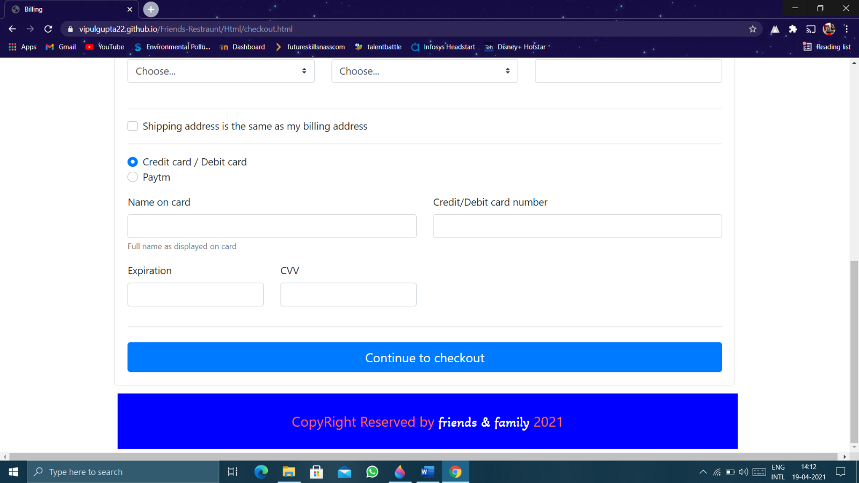

Footer Page:

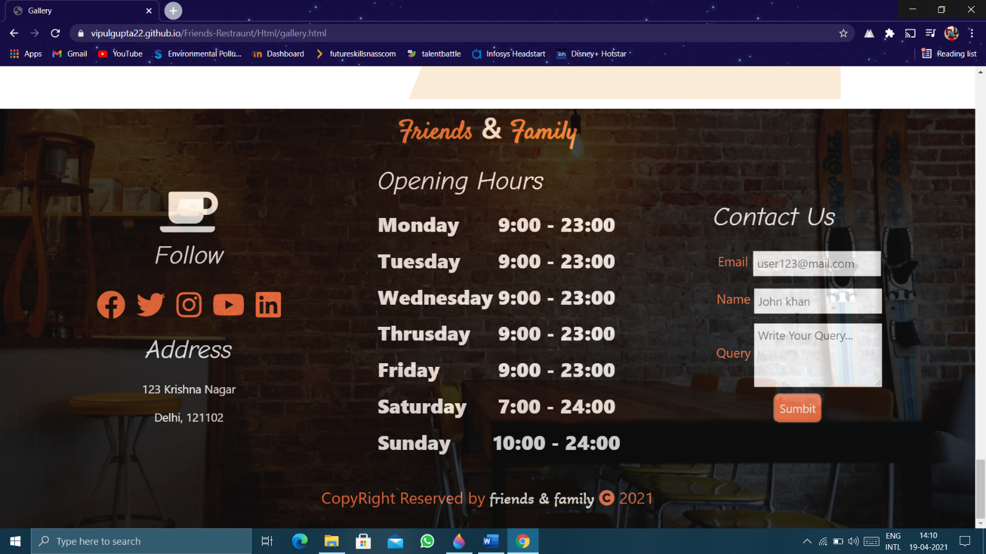

**Chapter-6**

**Contributions**

**Arvind Jaiswal**

He contributed Contact, Login and Signup Pages.

**Vipul**

He contributed Menu, Checkout Pages, Welcome Page and guided Satyam in his work.

**Umesh Pratap Singh**

He contributed About Us and Gallery Page and guided Arvind in his work.

**Satyam Singh**

He contributed Home Page and Navigation in all Pages.

**Chapter-7**

**References**

❖ www.javatpoint.com

❖ www.w3school.com

❖ www.tutorialspoint.com

❖ www.youtube.com